# FLEXBOX Intro

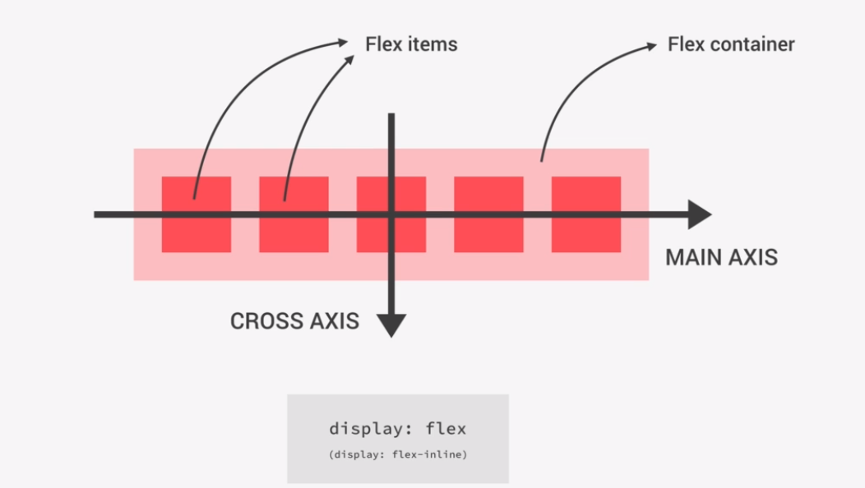

# Flexbox Properties CHEAT-SHEET

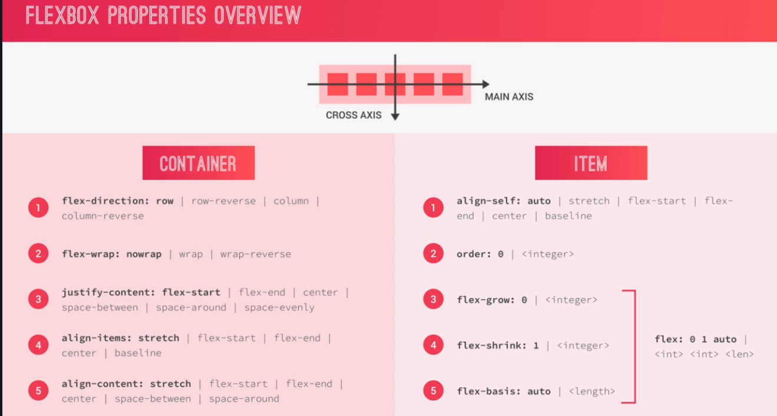

## Justify vs Align

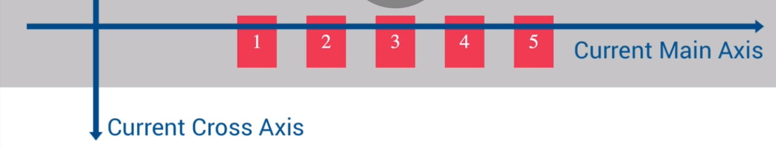

Remember that

* **justify** aligns element relative to the current MAIN-AXIS
* **Align** aligns elements relative to the current CROSS-AXIS

## Justify-content property

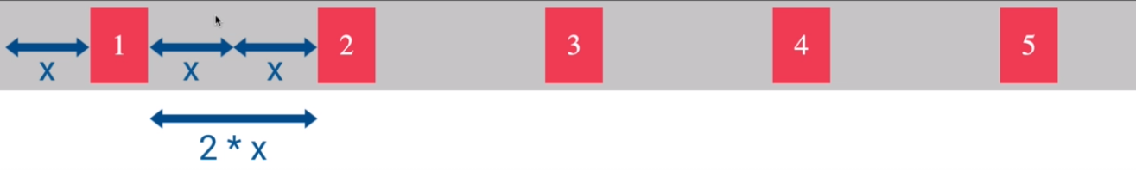**justify-content: space-around;**

**justify-content: space-evenly;**

**justify-content: center;** 

## Align-items property

The initial value on align-items is “stretch” On stretch all items “stretch” to fit the height of the container, or in other words the height of the element on the CrossAxis

**Align-items:center;**

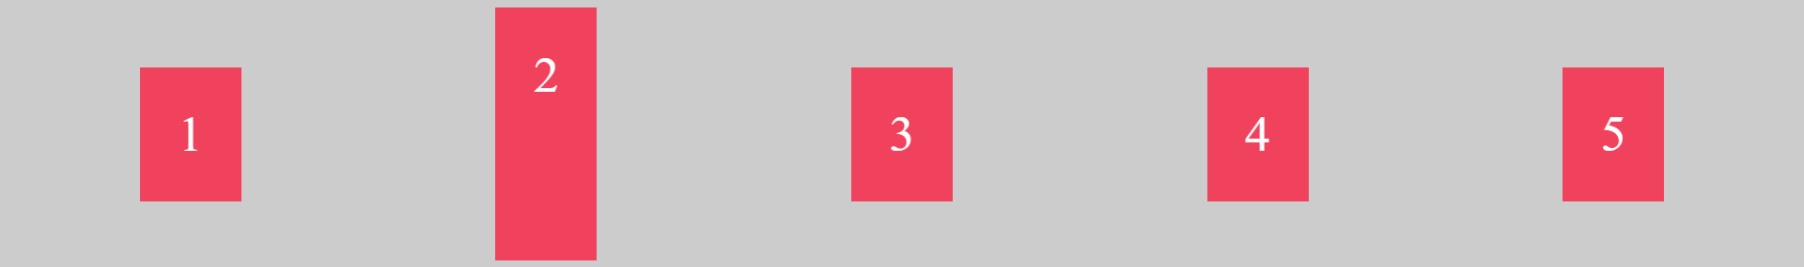

Align-items: flex-end

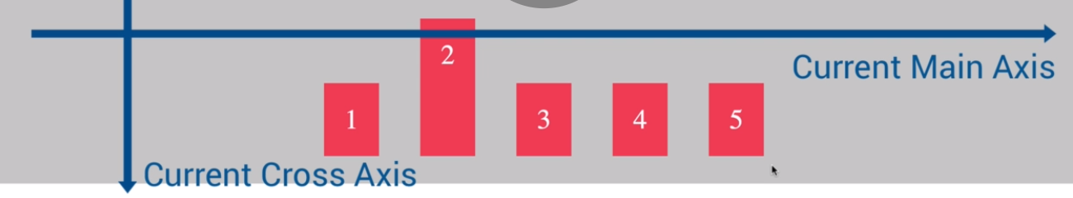

**Align-items: flex-start**

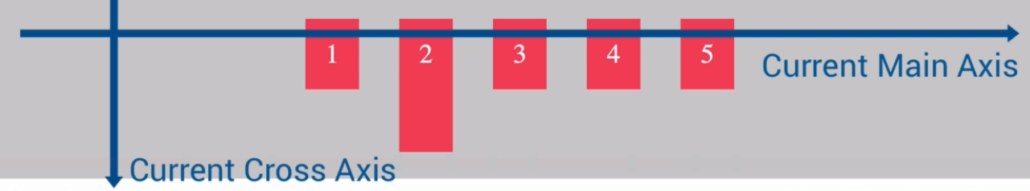

**Align-items:stretch (default)** Makes all the elements stretch to the height of the tallest element

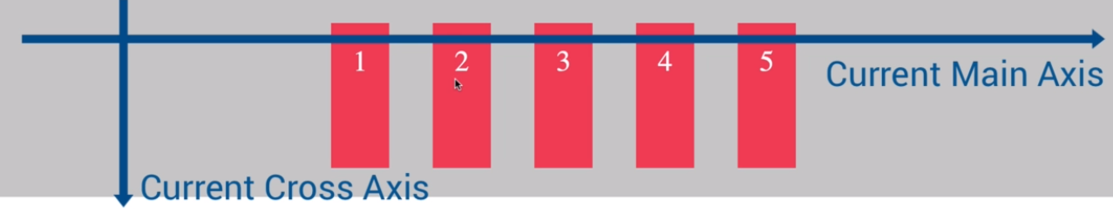

Align-items:baseline; Aligns the elements to the line of their common text.

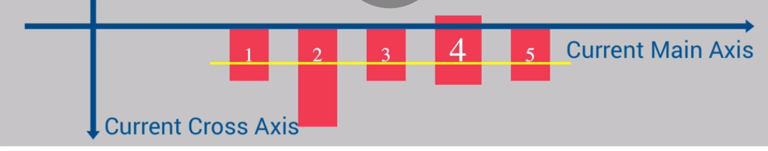

## Flex-direction

This property changes the direction and orientation of our Main and Cross Axis

**Reverse**  changes the direction 🡨 🡪 of our Axis

While **column** and **row** change the positions of the **Main** and **Cross axis**

So in **flex-direction: column**; our main axis is **vertical**

And in **flex-direction:row;** our main Axis is **horizontal**

**Flex-direction: column;**

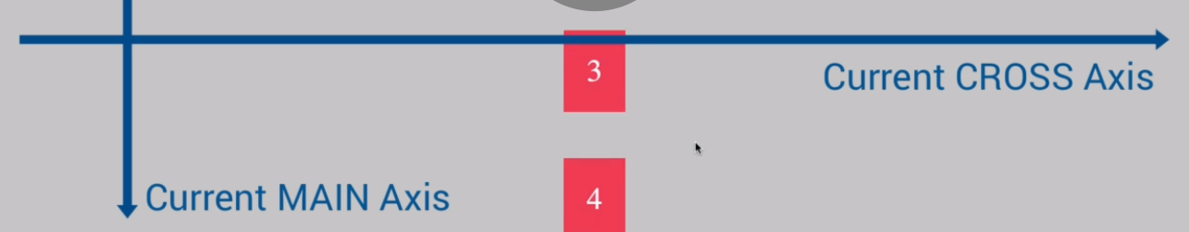

## Flex-grow

A simple shorthand to make any element take up as much remaining space as is possible within the parent container, is to sethim a property **flex-grow:1;**

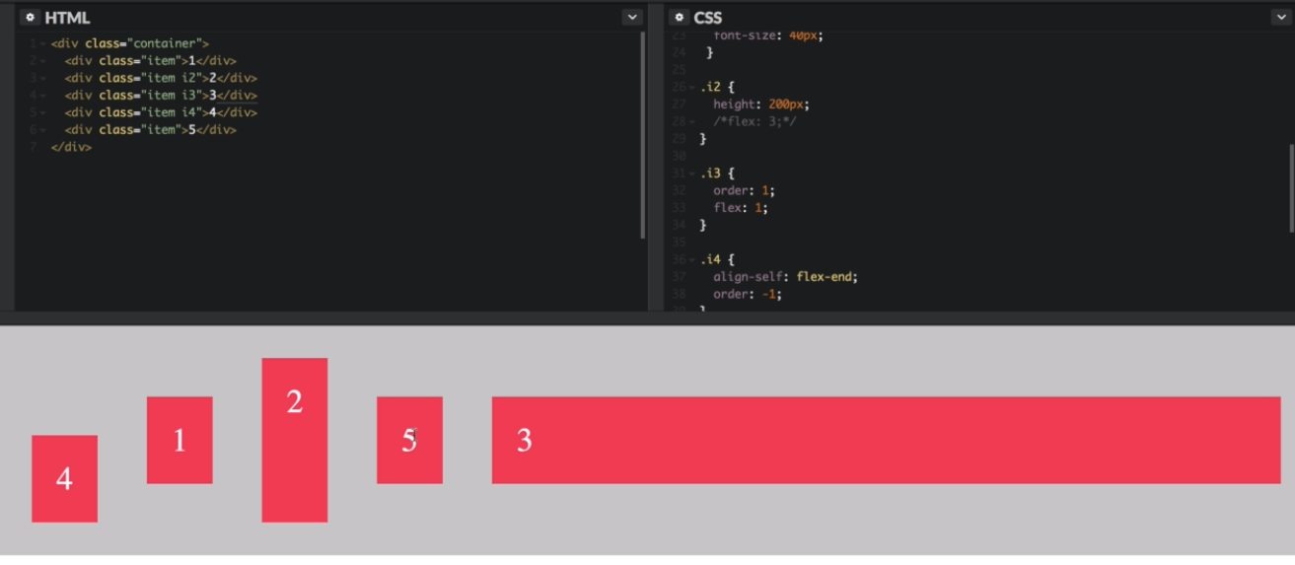

Works so long as all the other elements don’t have a set growth rate. If they do have a set growth rate, the following example applies 🡪

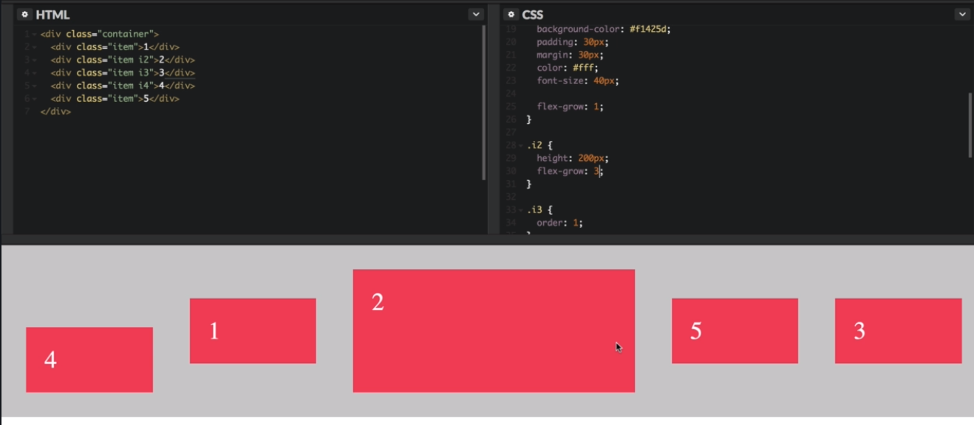

Flex growth rate is always relative to sibling elements growth rate. As in, if all the other elements (Sibling) have a growth rate of 1, the element with the growht rate of 3 will be 3 times as large, because 1 is three times the smaller growth rate than 3.

## Flex-basis

Basically, flex basis is a relative width that an element should be taking up within the parent container

Flex-basis:20%; 🡪 given to an element, means that it will shrink and expand with the parent, to always take up 20% of the container space.

**If given a pixel** value, it wil work just like **max-width;** works. It takes up the space it was assigned, if there is room enough to do so, and otherwise if the viewport is too small for it to take up 300px it will shrink to take up 100% of the available space left to it in the parent container.

Flex-basis:300px 🡪 will make the element take up 300px, as long as it is available.

### Flex-shrink

Sometimes, we don’t want our elements to shrink alongside the viewport, if the viewport becomes smaller than their flex-basis

Flex-shrink is by default 1 🡪meaning the element is allowed to shrink

If we don’t want an element to shrink, we simply need to set the flex-shrink to 0 **flex-shrink: 0;**

## **Flex(grow,shrink, basis) shorthand property**

Remembering that we shoud always use the shorthand property

Flex: flexGrow flexShrink flexBasis;

**flex: 0 0 300px**

## align-content property

Align content is a property set to the parent flex container (parent of flex elements) What it does is aligns entire rows (flex-element-sections) along the CROSS AXIS

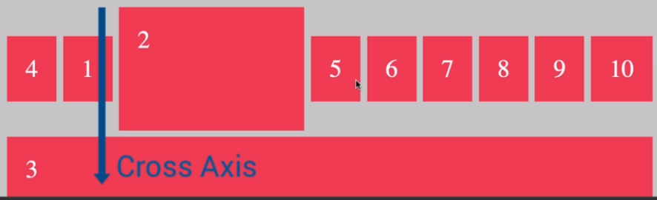

So if flex-direction is set to ROW, the align-content property will basically move the entire row or rows up for flex-start, down for flex-end and vertically center for center.

If the flex-direction is set to COLUMN, then align content does the same but horizontally (as the CROSS AXIS is now the horizontal axis) but for entire column/s,where flex-end becomes the right side, flex-start the left, and center, aligned to the center

It also has the following values: **Space-between, space-around** and **stretch(default value)**

The only differnce is with these values on align-content as opposed to align items, is that the spaces between and around are no longer created on individual elements, but between entire columns or rows, depending on the flex-direction property value.

## **Running SASS on a new project**

Simply copy the package.json file

Then install all of the packages by running

* **npm install**

in the command prompt of your new project folder, so the nodes (packages) get installed in a new node_modules folder of your current project directory

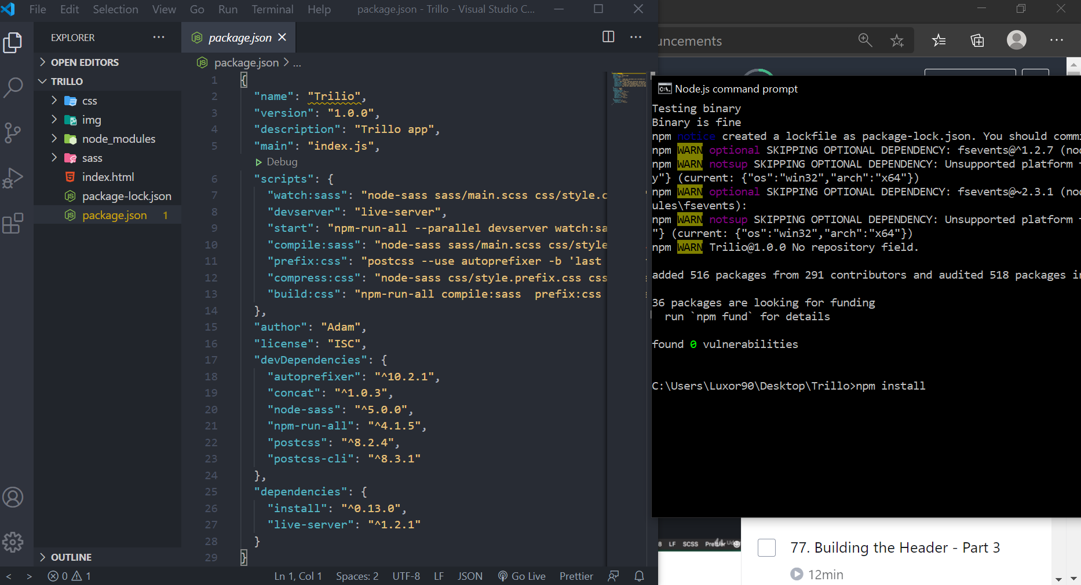

## CSS Variables (custom properties) vs SASS Variables

* Don’t need a preprocessor to be compiled
* They can be manipulated in Javascript
* Can be edited in our browser Dev-tools
* Easier to use inside the calc-function
* CSS variables cascade and are inherited whereas SASS are neither inherited nor do they cascade

The css-variables domain of accessability is always within the reach of the selector element. To make the variables accessible to the entire website, we declare them in the highest webpage parent element **:root{….}**  and now they are available to use throughout all of our website’s child elements

# TRILLO WEBSITE

### **Base scss**

:root {

  --color-primary: #eb2f64;

  --color-primary-light: #ff3366;

  --color-primary-dark: #ba265d;

  --grey-light-1: #faf9f9;

  --grey-light-2: #f4f2f2;

  --grey-light-3: #f0eeee;

  --grey-light-4: #ccc;

  --grey-dark-1: #333;

  --grey-dark-2: #777;

  --grey-dark-3: #999;

}

* {

  margin: 0;

  padding: 0;

}

html {

  box-sizing: border-box;

  font-size: 62.5%; //1rem = 10px, 10px/16 = 62.5%

}

*,

*::before,

*::after {

  box-sizing: inherit;

}

body {

  font-family: "Open Sans", sans-serif;

  font-weight: 400;

  line-height: 1.6;

  background-image: linear-gradient(*to* right bottom, var(--color-primary-light), var(--color-primary-dark));

  background-size: cover;

  background-repeat: no-repeat;

  min-height: 100vh; //Optionally remove after testing

}

### Example of using a flex-shorthand property

.sidebar {

  background-color: var(--color-grey-dark-1);

  flex: 0 0 18%; // --> shorthand flex: grow shrink basis;

  //Dont want it to grow if there is more space flex: 0;

  //We also don't want it to shrink if there is not enough space flex:0 0;

  //We always want to keep it at 18% of the parent container flex: 0 0 18%

}

flex: 0 0 18%; 🡪 Since it is a percentage defined as a flex basis, it is allright to define the flex-shrink at 0, because % is always relative to the size of the parent within the viewport, so if the viewport shrinks, so will the element, in order to remain at 18%.

**In other words, defining flex-basis in a percentage, means the element will still shrink.**

## Creating a basic layout (sidebar + mainElement) using Flexbox



////FLEX PARENT CONTAINER/////////////

.content {

  display: flex;

  flex-direction: row; //default

}

//Flex element1

.sidebar {

  background-color: var(--color-grey-dark-1);

  flex: 0 0 18%; // --> shorthand flex: grow shrink basis;

  //Dont want it to grow if there is more space flex: 0;

  //We also don't want it to shrink if there is not enough space flex:0 0;

  //We always want to keep it at 18% width of the parent container flex: 0 0 18%

}

//Flex element2 (<main> element

.hotel-view {

  background-color: #fff;

  background-color: orangered;

  flex: 1;

}

//////////////////////////////////////

## Using SVG images instead of ICON fonts for icons

Why is it better to use SVG? Well, icons fail more often than you’d, and the browser instead of the icon simply displays black squares. Also, icons cannot be read by screen readers to people with vision issues.

**Best practice is moving to SVGs instead of Icon-fonts**

What are these images? 🡪 **SVG(Scalable Vector Graphics)**

To access free SVG icons, or to convert your current icon-fonts into SVG visit: [Icon Font & SVG Icon Sets ❍ IcoMoon](https://icomoon.io/)

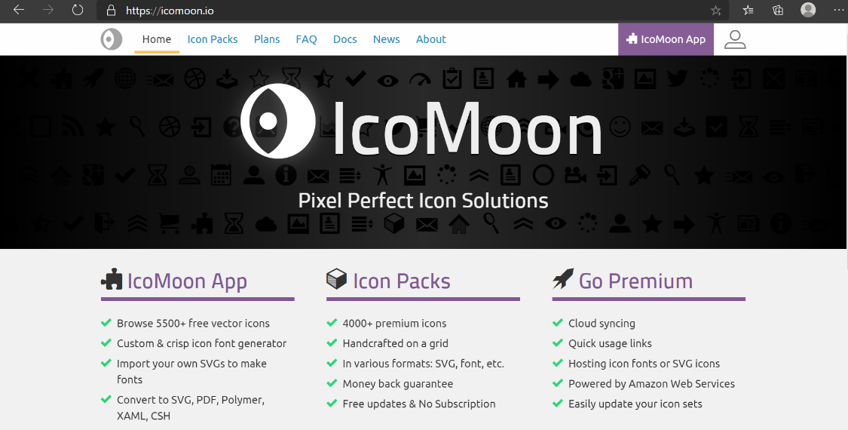

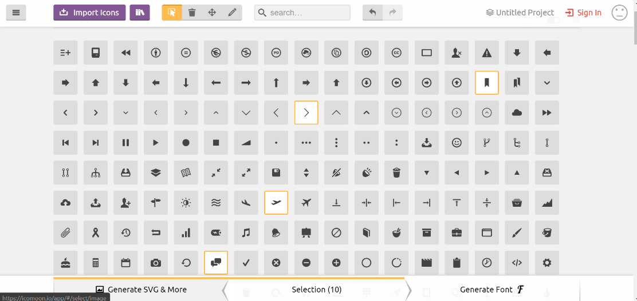

## Including SVG icons in your project folder and HTML

Basically, we go to the site , and inn the IcomonApp we select the type and shape of icon that we’d like to use in our website.

When you download the zip, simply select the SVG folder and the **symbol-def.svg**(simbol definitions) file 🡪 the file which allows all the svgs to be accessed from a single http-request instead of needing to make an http-request for each SVG icon we include on our website **symbol-def.svg 🡪** this file is usually called an svg sprite file, and we’ll be renaming it in our project folder accordingly.

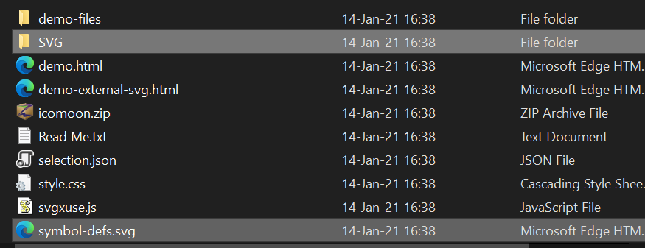

Paste the folder and the file within your **img** project file, but make sure to rename **symbol-def.svg 🡪 sprite.svg**

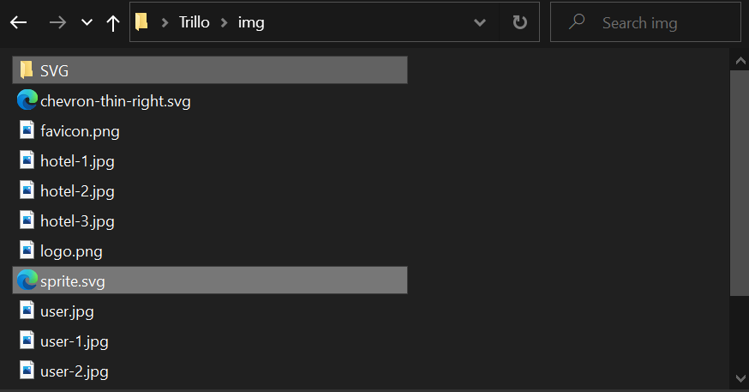

As we mentioned above, using the sprite file allows all our svg images links to go through the single file that redirects to the specific svg attached with the hash#. This makes the web-server load all svg’s from a single http request. **It should be noted:** that these SVG icons included using **xlink:href** only appear on web-servers (local server works too)

The example below is how we include images xlink:href=”spriteDirectory/spriteFile#IconName”

<!--Including SVG files-->

              <svg class="search__icon">

                <use xlink:href= "img/sprite.svg#icon-magnifying-glass"></use>

              </svg>

### Components file for the Trillo website

**Remember that components are supposed to be reusable throughtout various projects**

**Though in the Trillo Website, components represent component-parts of the Trillo website, not necessarily reusable and independent component-templates**

## **Using negative margins to overlap elements**

Negative margins basically increase or decrease the layout space our elements take up, without changing their visual appearance or size.

So a small element with a huge margin, may take up an entire page, though it will still appear small.

In the same way a huge element may have very large negative vertical and horizontal margins, meaning that as far as layout is concerned it is a tiny object on the page, and all other elements will ignore the visual edges of the object, acting as if the element is only as large as its tiny margins.

Now, why is this useful to know? Well, cause we can hack it^^

Usually to make sibling elements overlap we need to set one to a position relative or absolute, and manually position it over the element we want it to overlap.

But sometimes, the simpler solution is to use negative margins.



The **magnifying glass icon** is currently outside of our search box, but we want it to be within the search input-element. Our icon is currently just next to the input because they are sibling elements, and the input element takes up all the visual input area(it literaly takes up as much space as is visually represented/like elements usually do, without additional margins))

**Because of this our sibling elements are positioned next to each other.**

**Placing the icon over the input element:**

* One way to do this is to position the icon relative or absolute, and move it to overlap.
* The other way is to give the element that is supposed to get overlapped by another, a negative (in this case horizontal) margin, making the space it takes up on the page layout smaller than the width of the actual element. So our icon would get positioned relative to the negative margin and not the actual width of the input

&__input {

    //Remember that inputs don't inherit font properties by default

    font-family: inherit;

    font-size: inherit;

    color: inherit;

    background-color: var(--color-grey-light-2);

    padding: 0.7rem 2rem;

    border-radius: 100px;

    width: 90%;

    margin-right: -3.5rem;

 &__icon {

    height: 2rem;

    width: 2rem;

  }

}



## Aligning and Centering Elements Using Flexbox

Generally, now that we have flexbox available, any subtle or large aligning of items within their parent container should be done using flexbox properties, if our elements are flex elements. This is by far a simpler method to implement on most elements than positioning them as absolute elements within a parent and then using the absolute-center-align hack using the translate property.

### Flex-elements also functioning as flex-containers

Flex-elements are absolutely allowed to be flex-containers to their respective children. This means that we can nest flexboxes within each other, so that a flex element within a flex-box can be a flexbox for it’s own child-flex-elements.

To do this, we of course have to assign **display:flex** to the flex element in order to make it function as a flex-container as well as a flex-element.

.search {

  background-color: orangered;

  //Flex item properties

  flex: 0 0 40%; //noGrow NoShrink 40%Baseline

  //Flex-container property

  display:flex

}

## Direct decendent vs All decendent elements(REVISITED)

* Direct decendents of the header element

 header>*{

  }

* All decendents of the header element (child/grandchild, etc…Moves recursively down the elelement tree until it reaches the leaf with no decendants in all of the recursive branches it enters)

 header *{

  }

The rule is as following :

**A B { }**

B as a descendant of A

**A > B { }**

B as a direct child of A

So

**A * { }**

Anything as a decendant of A 🡪 All-child selector

## Using Flex-properties to center align Text within a container

Flexbox properties don’t just work on child elements, they also work on “textContent” of the container element itself

In this case we have number-characters within the textContent attribute of a <span> element, that we styled to appear as a rose colored circle <span class=”notification”>14</span>

Unfortunately the number-character inside it is not perfectly center aligned to the <span> element.

To fix this we can experiment with padding, and text-align:center, until we get the perfect position

Or as is the simpler way, implement the flex properties on the .**notification** <span> element.

.notification {

    font-size: 0.8rem;

    height: 1.75rem;

    width: 1.75rem;

    border-radius: 50%;

    background-color: var(--color-primary);

    color: #fff;

    position: absolute;

    top: 1.5rem;

    right: 1.1rem;



   // Flexbox for text

    display: flex;

    justify-content: center;

    align-items: center;

  }

## Creating Icons with notification bubbles(.user-nav)





.user-nav {

  background-color: var(--color-grey-light-3);

  align-self: stretch;

  display: flex;

  align-items: center; //vertically center flex-display:row

  //.user-nav > *{...}   ==> All children direct of .user-nav container

  // {icon-box} {user}

  & > * {

    padding: 0 2rem;

    cursor: pointer;

    height: 100%;

    display: flex;

    align-items: center;

    &:hover {

      background-color: var(--color-grey-light-3);

    }

  }

  &__icon-box {

    position: relative;

  }

  &__icon {

    height: 2.25rem;

    width: 2.25rem;

    fill: var(--color-grey-dark-2);

  }

  &__notification {

    font-size: 0.8rem;

    height: 1.75rem;

    width: 1.75rem;

    border-radius: 50%;

    background-color: var(--color-primary);

    color: #fff;

    position: absolute;

    top: 1.5rem;

    right: 1.1rem;

    // Flexbox for text

    display: flex;

    justify-content: center;

    align-items: center;

  }

  &__user-photo {

    height: 3.75rem;

    border-radius: 50%;

  }

  &__user-name {

  }

}

/////////////////////////HTML//////////////////////////////////////////////////////////////////

<nav class="user-nav">

          <!--Icon Box1-->

          <div class="user-nav__icon-box">

            <svg class="user-nav__icon">

              <use xlink:href="img/sprite.svg#icon-bookmark"></use>

            </svg>

            <!--Notification bubble-->

            <span class="user-nav__notification">7</span>

          </div>

## **Coloring and styling our SVG icons**

.icon {

    justify-self: center;

    height: 2rem;

    width: 2rem;

    fill: var(--color-grey-dark-3);

  }

Basically we give them a height and width just like any other non-container element. And to assign an icon a different color we simply use the **fill: var(--your-color);** property.

## **When to use AbsolutePosition and When to use Flex Positioning**

Remember that for fine tuning a very specific alignment, like positioning the pink bubbles over our icons, **absolute positioning** is still the best tool.

But for gros/general alignment, or even more specifically for equal alignment of elements alongside horizontal and vertical axis, nothing beats **flex-properties** as they are always exact to a pixel on the various global align positions space-between, **space-around, even-space, center, flex-end, flex-start**

### **CurrentColor property-value**

&__icon {

    //usually icons are sized to be squares

    width: 1.75rem;

    height: 1.75rem;

    margin-right: 2rem;

    fill: currentColor; //it is like inherit for color

    //Pastes the color of the parent element

  }

The property-value is well supported by current browsers and is in itself a way to make text color inheritable by the child from the parent. So if you want to color all your child elements the same color as that of their parent container, simply assign this value to the **color, fill …** text-color border, background to **current** color and it will inherit the current **color** property value.

It is especially useful for using in :hover states of elements, when we want to change the color of an icon the moment the related text changes. Instead of using complex selectors to change icon color whenever their anchor sibling is hovered

**.linkParent(color:var(--link-color);}**

**.iconChild{color:var(--link-color);}**

**.linkParent:hover{color:var(--new-link-color);}**

**.link:Parent:hover .icon{color: var(--new-link-color);}**

We simply give the .icon the color of current color, and their colors are now connected and will automatically match each other without any need for creating any more pseudo-class selectors.

**.iconChild{color:currentColor**

**.linkParent:hover{color:var(--new-link-color);}**

Note using current color for background, border,etc. 🡪 Will set the current text color to the border, background, etc… **CURRENT COLOR IS ALWAYS THE CURRENT text-color**

## Z-index (REVISITED)

Rememeber that z-index only works when we have the **position property specified!**

Why is this the case? Well, Z-index tells our elements how many levels it is above or below our normal document layer. 0-default is when our element is on the same level as the html document itself, -5 is five layers below it, while 5 is five layers above it.

That said, our elements cannot be pushed a level above or below our html page, unless a position value has been set. Position value alows our elements to move top,bottom, left right, around their curren layout, but it also alows for the element to completely move to another layer (level) either by position:absolute; or by using the **z-index** property.

**So in order to use z-index we must always define the position property for that element!**

 h1{

position: relative;

     z-index: 10;

}

## **Styling pseudo element’s pseudo-class**

Just like we can style pseudo classes :hover :active, etc…

We can also style how pseudo-elements ::before ::after behave and look when their reference element (pseudo-parent) is in special state like :checked :validated :hover :active :focus etc in the following manner

.parent:active::before {

      background-color: transparent;

    }

//When the parent is clicked the :before pseudo element of the parent will change background

.parent:focus::before {

      outline: 1px solid black;

    }

//When parent is in focus, its before element will get an outline

.parent:hover::before {

      background-color: var(--color-primary-light);

    }

## **Creating a side-nav using flexbox**

 <nav class="sidebar">

          <ul class="side-nav">

            <!--Nav-Item 1-->

            <li class="side-nav__item--active">

              <a href="#" class="side-nav__link">

                <svg class="side-nav__icon">

                  <use xlink:href="img/sprite.svg#icon-home"></use>

                </svg>

                <span>Hotel</span>

              </a>

            </li>

            <!--Nav-Item2 -->

            <li class="side-nav__item">

              <a href="#" class="side-nav__link">

                <svg class="side-nav__icon">

                 <use xlink:href="img/sprite.svg#icon-aircraft-take-off"></use>

                </svg>

                <span>Flight</span>

              </a>

            </li>

            <!--Nav-Item3 -->

            <li class="side-nav__item">

              <a href="#" class="side-nav__link">

                <svg class="side-nav__icon">

                  <use xlink:href="img/sprite.svg#icon-key"></use>

                </svg>

                <span>Car rental</span>

              </a>

            </li>

            <!--Nav-Item4 -->

            <li class="side-nav__item">

              <a href="#" class="side-nav__link">

                <svg class="side-nav__icon">

                   <use xlink:href="img/sprite.svg#icon-map"></use>

                </svg>

         <span>Tours</span>

          </a>

</li>

</ul>

          <!--Copyright text declaration-->

          <div class="legal">&copy; 2020 by trillo. All rights reserved</div>

 </nav>

/////SIDE NAVIGATION

.side-nav {

  font-size: 1.4rem;

  list-style: none;

  margin-top: 3.5rem;

  &__item {

    position: relative;

    &:not(:last-child) {

      margin-bottom: 0.5rem;

    }

    &--active {

      background-color: var(--color-primary);

    }

    &::before,

    &--active::before {

      content: "";

      position: absolute;

      top: 0;

      left: 0;

      height: 100%;

      width: 3px;

      background-color: var(--color-primary);

      transform: scaleY(0);

      transition: transform 0.2s cubic-bezier(1, 0, 0, 1), width 0.4s 0.2s cubic-bezier(1, 0, 0, 1), background-color 0.1s;

    }

    &:active::before {

      background-color: var(--color-primary-light);

    }

    &:hover::before {

      transform: scaleY(1);

      width: 100%;

    }

  }

  &__link:link,

  &__link:visited {

    color: var(--color-grey-light-1);

    text-decoration: none;

    text-transform: uppercase;

    display: block;

    padding: 1.5rem 3rem;

    position: relative;

    z-index: 10;

    display: flex;

    align-items: center;

  }

  &__icon {

    //usually icons are sized to be squares

    width: 1.75rem;

    height: 1.75rem;

    margin-right: 2rem;

    fill: currentColor; //it is like inherit for color

  }

}

## Creating a simple image galery using Flexbox

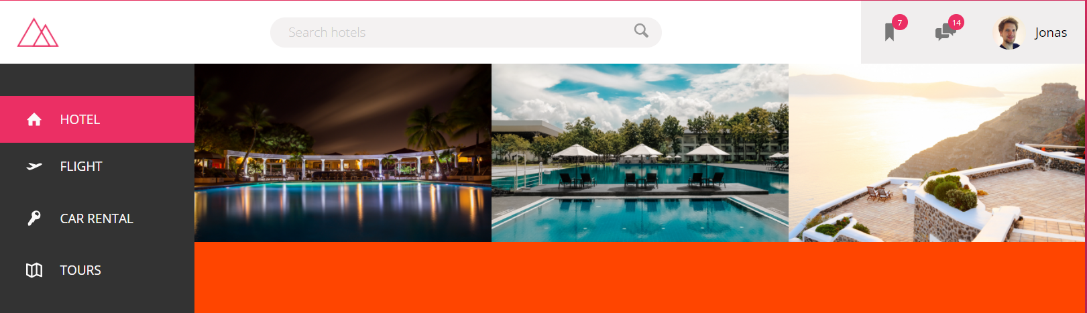

//////////////////////////////////

/////GALLERY

.gallery {

  display: flex; //default flex-direction:row;

  &__photo {

    //Remember that responsive images are always

    //created by defining width or height in %

    width: 100%;

  }

}

 <main class="hotel-view">

          <div class="gallery">

            <!--Images wrapped in a figure element so that we can add figCaption to the images-->

            <figure class="gallery__item">

              <img src="img/hotel-1.jpg" alt="" class="gallery__photo" />

            </figure>

            <figure class="gallery__item">

              <img src="img/hotel-2.jpg" alt="" class="gallery__photo" />

            </figure>

            <figure class="gallery__item">

              <img src="img/hotel-3.jpg" alt="" class="gallery__photo" />

            </figure>

          </div>

        </main>

Note that the <main> tag is the orange element, or the main right side of the page

## **Creating responsive images (REVISITED)**

.photo {

    //Remember that responsive images are always

    //created by defining width or height in %

    width: 100%;

    display: block;//removes unwanted whitespace around image

  }

* Width has to be set in percentage so that it scales up and down with the parent container
* Has to be displayed as a block-level element so that there are no gapsin the container below the image or around the image.

### **Fixing unwanted white-space around images**

Images are by default inline level elements:

**Basically to fix any image glitches display them as block or inline-block elements, if we don’t want any whitespace around them**

## How to create infinite animation

## **Using margin: auto; with flexbox, and why it’s so powerful**

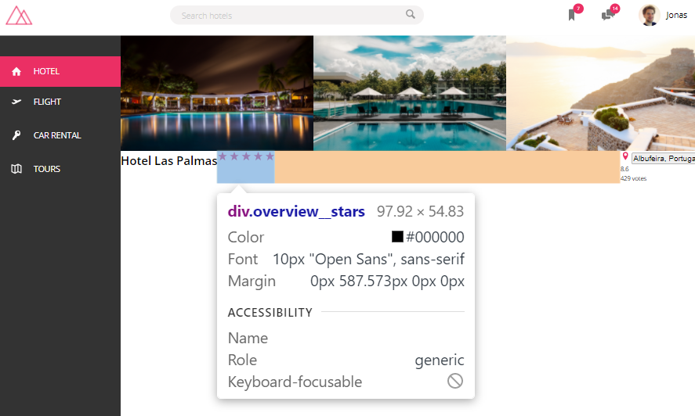When we have a situation where we want to create empty space between to elements, but we absolutely don’t want to stretch our element containers, to fill out that empty space, (or worse use ::before ::after pseudo elements)

The best solution that we can have is to either, group the empty elements into two bigger containers, so that our parent element has only two direct child elements, that between them contain all of the elements that we want to move to the sides. **In this case the first div would have the heading and the stars, while the second would have the location icon, button and address,** then use the justify-content:space-between 🡪 Which would allocate all the available parent container space to be between the two divs dividing all the smaller elements between them**.**

**Or much more simply** USE MARGIN(LEFT/RIGHT/TOP/BOTTOM): AUTO on a flex element within the container.

Flex elements with the margin auto allocate all the free space within the container to that margin, so instead of having one

* flex-Parent-container > Two decendant Flex container > (n)flex allocated within them them

We’d be having

* One parent flex container > (n) flex elements within them 🡪 MUCH MORE STRAIGHTFORWARD

.overview {

  display: flex;

  justify-content: space-between;

  &__heading {

  }

  &__stars {

    margin-right: auto;

  }

  &__icon-star,

  &__icon-location {

    width: 1.75rem;

    height: 1.75rem;

    fill: var(--color-primary);

  }

**How it looked before the 🡪 margin-right:auto;**

**What it looks like after the margin is applied**



<div class="overview">

            <h1 class="overview__hicon-eading">Hotel Las Palmas</h1>

            <!--Stars-->

            <div class="overview__stars">

              <!--Star-->

              <svg class="overview__icon-star">

                <use xlink:href="img/sprite.svg#icon-star"></use>

              </svg>

              <!--Star-->

              <svg class="overview__icon-star">

                <use xlink:href="img/sprite.svg#icon-star"></use>

              </svg>

              <!--Star-->

              <svg class="overview__icon-star">

                <use xlink:href="img/sprite.svg#icon-star"></use>

              </svg>

              <!--Star-->

              <svg class="overview__icon-star">

                <use xlink:href="img/sprite.svg#icon-star"></use>

              </svg>

              <!--Star-->

              <svg class="overview__icon-star">

                <use xlink:href="img/sprite.svg#icon-star"></use>

              </svg>

            </div>

            <div class="overview__location">

              <svg class="overview__icon-location">

                <use xlink:href="img/sprite.svg#icon-location-pin"></use>

              </svg>

              <button class="btn-inline">Albufeira, Portugal</button>

              <!--OVERVIEW RATING-->

              <div class="overview__rating">

                <div class="overview__rating-average">8.6</div>

                <div class="overview__rating-count">429 votes</div>

              </div>

            </div>

          </div>

Note that the exact same effect could have been created on using margin-left:auto; on the far right element. Also it is important to mention how adding marigins and padding to our individual flex elements, of course changes the margin:auto; since aditional margins on other elements of course leave less space to be allocated to the auto margin, but since that is the case, it simply means that we can continue to play around with all of our elements, and the maring-auto; will adjust accordingly. It is in all meanings of the word, quite a flexible hack!

## **Removing default whitespace (around/above/below) SVG icons**

Baically all SVG icons, appear with womewhat of a padded element design, so if we want them to be exactly as wide./tall as the icon itself we can do two things

* Set the SVG – icon line-height and font-size to 0;
* Giving the SVG parent element display:flex;

## **Creating an infinite animation**

.btn-inline {

  border: none;

  color: var(--color-primary);

  font-size: inherit;

  border-bottom: 1px solid currentColor;

  display: inline-block;

  background-color: transparent;

  cursor: pointer;

  transition: all 0.2s;

  &:hover {

    color: var(--color-grey-dark-1);

  }

  &:focus {

    outline: none;

**animation: pulsate 1s infinite;**

  }

}

///////////////

////Animations

@keyframes pulsate {

  0% {

    transform: scale(1);

    box-shadow: none;

  }

  50% {

    transform: scale(1.05);

    box-shadow: 0 1rem 4rem rgba(black, 0.25);

  }

  100% {

    transform: scale(1);

    box-shadow: none;

  }

}

Basically our keyframe has to have default state for 0% and 100%, and all in between states will represent the animation itself. As longs as start(0) and end(100) state are the object’s default state, the animation will appear to restart each time it runs, if we loop it more than once. If we want infinite animations we simply

## **Vertically aligning child items using Flexbox**

.parent {

    display: flex;

    align-items: center;

  }

When we want the child items in the normal flex-direction: row; layout to be on the same vertial level with each other. In other words, if we want all the elements inside a row to be in the same line, just allign them all to the vertical center of the parent container using **align-items: center;**

### **Making an element stretch vertically to fully fill up its current container**

What we have here is a <div.rating> and unfortunately as you can see, the contenet of the div does not fill up the full vertical space of the flex-parent row that it is positioned in, below the picture.

To fill up this row vertically we simply apply the **align-self: stretch** property to the individual element, in this case the **rating** container

.rating {

    background-color: var(--color-primary);

    color: #fff;

    margin-left: 3rem;

    align-self: stretch;

  }

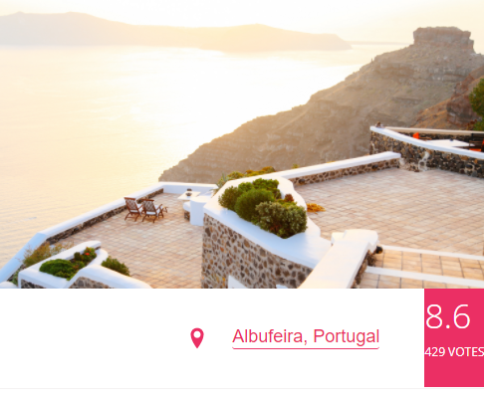Also note how the location description is vertically aligned within the parent row using the align-items property, that we mentioned in the previous heading.

Worth mentioning is that all of the elements within the row follow the parent’s align-items:center, which is why our element originally did not stretch to the bottom or the top of the parent. Giving the .rating element a align-self:stretch, overwrites the parent’s style for the flex elements, and gives us the desired style for both or row child elements, as well as the .rating element

## **Variables containing other variables**

Note that it is perfectly fine if your variable contains more than one value, as the exact line of code is what your css-variable contains, and not a specific datatype, and in that case consider a css variable as one that contains a string, when the variable is called if the string makes sense where the variable was passed it works (CSS is a simple text-format after all) 🡪 All strings and no datatypes, until compiled by the browser.

:root {

  --line: 1px solid var(--color-grey-light-2);

}

## **Sizing your sections and boxes (REVISITED)**

**Always remember, we want our content to define the size of our boxes and sections!!! For testing set a min-height, but be sure that when you finish the container , its size is defined by the elements within it, and the padding it contains.**

## **Last-child vs last-of-type**

////////////////////////////////

///////////PARAGRAPH

.paragraph:not(:last-of-type) {

  margin-bottom: 2rem;

}

Last-of-type: applies the style to the last element of a specified type, within the selector-container

Last-child: applies a style to the last element, of any type within the selector-container

## **Style rows of list elements side by side using flex:-wrap:wrap;**

//////LIST

.list {

  list-style: none;

  margin: 3rem 0;

  padding: 3rem;

  border-top: var(--line);

  border-bottom: var(--line);

  display: flex;

  flex-wrap: wrap; // allows elements to move into new lines

  &__item {

    flex: 0 0 50%; //if we want to have two elements side by side

  }

}

This is how our list looks by default (we removed the bullets) Now, what we want to do with this list of 8 elements is to have 4 of them appear in two columns side by side, adjacent to one another.

Figure Step 1

🡨

For this purpose we will utilize the flex-wrap property. Passing it the value of wrap.

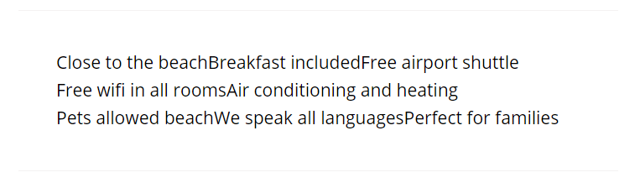Now that we’ve added 🡪

Figure Step2

display: flex; flex-wrap: wrap; these properties the display:flex made all of the elements fit inside a single row, and the **wrap** made the space between elements non-existant, so they all line up next to each other completely flush

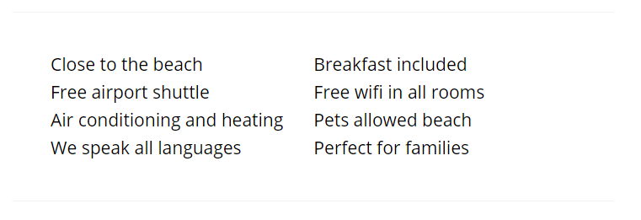Adding each element of the list a flex basis of 50% 🡪 basically max-width50% of the parent

Figure Step-3

We made sure that only two elements fit into a single row before flex wrap has to wrap them to the next line, and this is the final effect we were looking for ^_____^

### Aside about sizing images in height and width (REVISITED) Notice that small photos inside containers are very often sized in both height and width. It is a common practice and not all images have to be responsive

 &__photo {

    height: 4.5rem;

    width: 4.5rem;

  }

## **Implementing SVG images from css**

There are two ways to implement SVG from css. The first way is linking them as a background image to a ::before or ::after element, of the element that we want to add the icon to.

-This method works really well with older browsers, but the problem is that background image Icons cannot be colored, because adding a linear gradient to background image, will cover both the SVG icon and the background around it.

-In order to visibly cover an svg-icon we need to use masks, and this approach is suitable only for modern browsers as of 2017.

&__item {

    flex: 0 0 50%; //if we want to have two elements side by side

    margin-bottom: 0.7px;

  }

  &__item::before {

    content: "";

    display: inline-block;

    height: 1rem;

    width: 1rem;

    margin-right: 7px;

    //Including SVG's in older browsers

    // background-image: url(../img/chevron-thin-right.svg);

    // background-size: cover;

    //Newer Browser SVG inclusion - MASKS

    background-color: var(--color-primary);

    -webkit-mask-image: url(*../img/chevron-thin-right.svg*);

    -webkit-mask-size: cover; //makes the mask cover the entire element

    mask-image: url(*../img/chevron-thin-right.svg*);

    mask-size: cover;

  }

}

Modern browsers basically use **mask-image** property that basically places a mask over the background color that is placed over the SVG image just before

background-color: var(--color-primary);

mask-image: url(*../img/chevron-thin-right.svg*);

What the mask-image property does is make the entire image white, except where the icon-vector appears on the SVG image. Now since the background over the vector-icon is colored, that background will stay over the vector-icon as it cuts throught the white mask

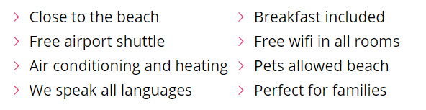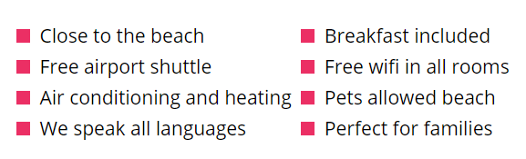

Figure Step2: Overlaying a white mask over the entire image, vector cutting through

Figure Step1: Adding a background-color over the SVG icon

Note that if we don’t set **mask size: cover;** 🡪 very small SVG’s may not appear fully, in those cases that we want to make our svgs 5px or so… So if the mask glitches add (mask-size:cover)

## **Overlaying images without using absolute positioning**

 &__photo {

    box-sizing: content-box;

    height: 4rem;

    width: 4rem;

    border-radius: 50%;

    border: 2px solid #fff;

    //Making the images overlap over each other

    &:not(:last-child) {

      margin-right: -1.5rem;

    }

  }

Basically we need to place the images in a row or column (adjacent to one another), so that by removing their margins from one side, the images clump closer together (cliping over each other) since their object size is now smaller then the visible borders of the image itself.



Without negative margins the pictures are at the distance of their normal, generally visible box-sizes



After applying the 🡪 margin-right: -1.5rem; we can see that the images behave as if they are much smaller than they actually are, and so clump over one another, The cut-out effect is achieved simply by having a white border, the images are actually one on top of the other in the order that they’ve been marked-up in the html 🡪 the first inserted image is at the bottom, and the last inserted image is on the very top.

### **Alternative to maintaining the object size when adding/removing borders**

In the case that we have our default box-sizing: box-sizing:content-box; adding a border to an element will make the element wider/taller by as many px as the border has. So usually adding a border to an element will make its box larger by element-size + border-size

Not so with box-sizing: border-box: 🡪 Adding a border to an element with this property value, will make it’s content value shrink so that the element maintains it’s current overal size.

This means that adding a border to the images above, if they have set box-sizing:border—box; will actually shrink the images (whole element actually) by as many pixels as the border you’ve passed it adds.

* In the case we don’t want our content to shrink when adding broders we should set the element to box-sizing: content-box;
* Alternatively if we don’t want our element to change size when when adding a border, margin or padding to it, we should set it to box-sizing: border-box.

## Trillo user-reviews(COMPONENT

 <!--USER REVIEWS-->

            <div class="user-reviews">

              <!--A User Review-->

              <figure class="review">

                <blockquote class="review__text">

                  Lorem ipsum, dolor sit amet consectetur adipisicing elit. Praesentium necessitatibus molestiae, pariatur, fuga, consequuntur

                  asperiores dolorum nobis qui fugiat ducimus nulla tempore voluptatum.

                </blockquote>

                <figcaption class="review__user">

                  <img src="img/user-1.jpg" alt="User 1" class="review__photo" />

                  <div class="review__user-box">

                    <p class="review__user-name">Nick Smith</p>

                    <p class="review__user-date">Feb 23rd, 2017</p>

                  </div>

                  <div class="review__rating">7.8</div>

                </figcaption>

              </figure>

              <!--A User Review-->

              <figure class="review">

                <blockquote class="review__text">

                  Lorem ipsum, dolor sit amet consectetur adipisicing elit. Praesentium necessitatibus molestiae, pariatur, fuga, consequuntur

                  asperiores dolorum nobis qui fugiat ducimus nulla tempore voluptatum.

                </blockquote>

                <figcaption class="review__user">

                  <img src="img/user-2.jpg" alt="User 1" class="review__photo" />

                  <div class="review__user-box">

                    <p class="review__user-name">Mary Thomas</p>

                    <p class="review__user-date">Sept 13th 2017</p>

                  </div>

                  <div class="review__rating">9.3</div>

                </figcaption>

              </figure>

            </div>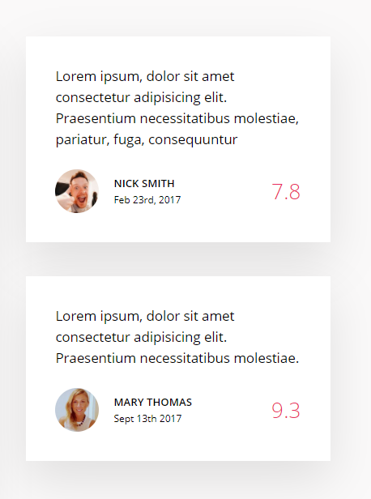

////////////////////////////////////

//////REVIEWS

.review {

  display: flex;

  flex-direction: column;

  justify-content: space-around;

  background-color: #fff;

  box-shadow: var(--shadow-light);

  padding: 3rem;

  margin-bottom: 3.5rem;

  &__text {

    margin-bottom: 2rem;

  }

  &__user {

    display: flex;

    align-items: center; //Vertically align items

  }

  &__photo {

    height: 4.5rem;

    width: 4.5rem;

    border-radius: 50%;

    margin-right: 1.5rem;

  }

  &__user-box {

    display: flex;

    flex-direction: column;

  }

  &__user-name {

    text-transform: uppercase;

    font-size: 1.1rem;

    font-weight: 600;

    margin-bottom: 0.4px;

  }

  &__user-date {

    font-size: 1rem;

    color: var(--color-gray-dark-3);

  }

  &__rating {

    color: var(--color-primary);

    font-size: 2.2rem;

    font-weight: 300;

    margin-left: auto; //making a white space between it and adjacent element

  }

  //CREATING THE LARGE QUOTATION MARKS

  &::before {

    content: "";  }}

## **Using the <figure> tag**

              <figure class="review">

                <blockquote class="review__text">

                  Lorem ipsum, dolor sit amet consectetur adipisicing elit. Praesentium necessitatibus molestiae, pariatur, fuga, consequuntur

                  asperiores dolorum nobis qui fugiat ducimus nulla tempore voluptatum.

                </blockquote>

                <figcaption class="review__user">

                  <img src="img/user-1.jpg" alt="User 1" class="review__photo" />

                  <div class="review__user-box">

                    <p class="review__user-name">Nick Smith</p>

                    <p class="review__user-date">Feb 23rd, 2017</p>

                  </div>

                  <div class="review__rating">7.8</div>

                </figcaption>

              </figure>

It should be carefully noted that the <figure> tag is not reserved only for capitoning images, it is in fact a great html-syntax tag for defining, article-preview cards, reviews and similar components of a section that may have an image with a related header, paragraph and other elements in the image description, making it a component, more than a caption (a card basically). So if you are inclined to use a <div> to make the image+content cards or user-review-components, know that you can also use the <figure> tag and its related <figcaption> child element, to syntax-define these components more precisely to the browser’s search engine.

## **Creating special characters in css**

Visit the css-tricks website: [Glyphs | CSS-Tricks (css-tricks.com)](https://css-tricks.com/snippets/html/glyphs/) to find the code snippets of special html characters both for including them in css and in html

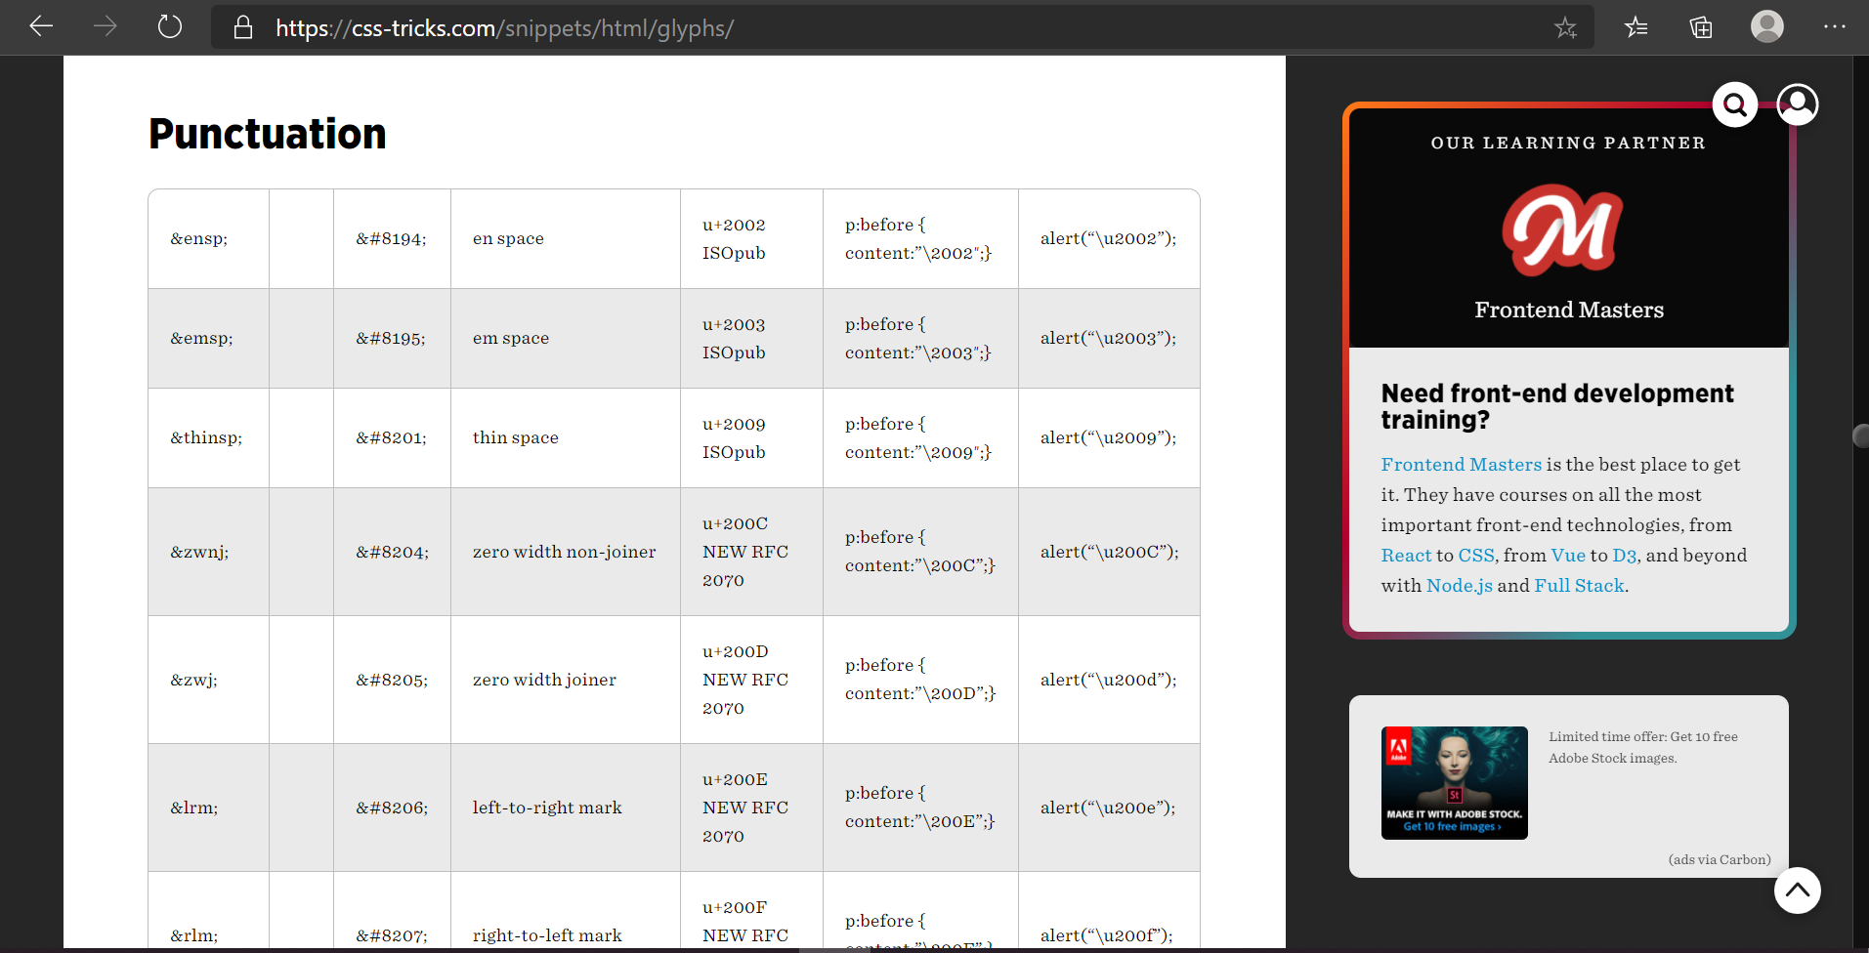

Next we will be using them to create a huge Quotation-mark before element for our review-component.

### **Including special characters in css**

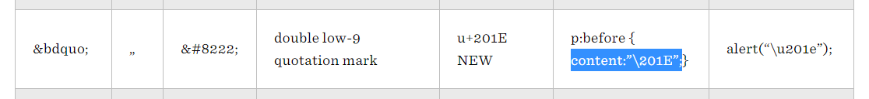

Basically in css these special characters are included by defining them as a :before 🡪 element’s content property-value. So if we want an empty :before div like element we leave content empty as so: content: “”; But if we want to make that :before div the shape of a special character, we can define the content property of the :before element as follows: **content:”\201E”; 🡪** This number is called the element’s **ISO** number.

//CREATING THE LARGE QUOTATION MARKS

.review{

  &::before {

    content: "\201e";

    display: absolute;

    top: -1.75rem;

    left: -1rem;

    font-size: 20rem;

    color: var(--color-grey-light-2);

    font-family: sans-serif;

    line-height: 1;

    //remember to decrease line height when positioning special characters

    //since they by default come with a HUGE line height

    z-index: 1;

  }

}

## Defining the size of an element using padding

 .button {

    display: inline-block; //so that we can use padding for our <span>

    padding: 2rem 7.5rem; //we are defining the size of the button with padding

  }

Sometimes we may want to define the size of an element (defined by its inner content) simply by increasing its padding. Larger padding === more inner content 🡪 larger element

## Creating the call to Action section (COMPONENT)



On hover the background changes and a new text drops from top as the old moves down.



 <!--CALL TO ACTION (cta) SECTION-->

          <div class="cta">

            <h2 class="cta__book-now">Good news! We have 4 free rooms for your selected dates</h2>

            <button class="btn">

              <span class="btn__visible">Book now</span>

              <span class="btn__invisible">Only 4 rooms left</span>

            </button>

          </div>

////////////////////////////////////

//////CALL TO ACTION (cta)

.cta {

  padding: 3.5rem 0;

  text-align: center;

  &__book-now {

    font-size: 1.5rem;

    font-weight: 300;

    text-transform: uppercase;

    margin-bottom: 2.5rem;

  }

}

.btn {

  font-size: 1.5rem;

  font-weight: 300;

  text-transform: uppercase;

  border-radius: 100px;

  border: none;

  background-image: linear-gradient(*to* right, var(--color-primary-light), var(--color-primary-dark));

  position: relative;

  overflow: hidden; //hides the span element that is currently invisible

  cursor: pointer;

  &__visible {

    display: inline-block; //so that we can use padding for our <span>

    padding: 2rem 7.5rem; //we are defining the size of the button with padding

    transition: all 0.2s;

  }

  & > * {

    //Selects __invisible and __visible

    height: 100%;

    width: 100%;

    transition: all 0.2s;

  }

  &__invisible {

    display: inline-block;

    position: absolute;

    left: 0;

    top: -100%; //moves the exact size of the element to the top

    //so if the element is 100px it will move 100px to the top

    padding: 2rem 0;

    //We want our hidden element to have a slightly smaller padding

    //so that it doesn't push into the visible element with its padding

  }

  &:hover {

    //We want the background gradient to move to the opposite side on hover

    background-image: linear-gradient(*to* left, var(--color-primary-light), var(--color-primary-dark));

  }

  &:focus {

    outline: none;

    animation: pulsate 1s infinite;

  }

  //The hover transitions will be done one way for the visible and another

  //for the invisible element, since the first is absolutely positioned

  //and the second element is not.

  &:hover &__visible {

    //The visible is not absolutely positioned so we use translate

    transform: translateY(100%);

  }

  &:hover &__invisible {

    //we differently absolutely position the invisible element

    top: 0;

  }

}

# Writing Trillo Media Queries

## Using variables to set media query breakpoints

Media queries do not allow us to pass CSS custom properties (CSS Variables), so the only way to pass it a variable is to create a SASS variable and pass that instead.

## Writing simple media queries

 @media only screen and (max-width: $bp-largest) {

    //breakpoint at 1200px

    margin: 0;

    max-width: 100%;

    width: 100%;

  }

Here we can see that a SASS variable has been passed as well as notice the standard media query syntax, when we are not using a media query manager as a MIXIN.

## Aligning Nav-items so they take up the full row space



&__nav-item {

@media only screen and (max-width: $bp-medium) {

      flex: 1;

      //make each element take up the  same space

      //until the parent is 100%;

      // the same effect would be flex-basis:25% but if we had

      //more than 4 elements it would not work as width25% would make them overflow

      // **flex**:1; on the other hand, works even if we add more nav elements in the future

      flex-basis: 25%;

    }

How it looks after we’ve added the @media query



## Remembering the order of writing media queries (REVISITED)

.detail {

  display: flex;

  font-size: 1.4rem;

  padding: 4.5rem;

  background-color: var(--color-grey-light-1);

  border-bottom: var(--line);

  //First we put the media query for the larger screen

  @media only screen and (max-width: $bp-medium) {

    padding: 3rem;

  }

  //Then we put the media query for the smaller screen

  @media only screen and (max-width: $bp-small) {

    flex-direction: column;

    //Both media queries will apply for 600px and lower

    //but if there are any conflicting rules, the 600px will have precedence

  }

}

As a rule we want to make additional changes when writing media queries for an even smaller screen(if there is more than one) and if those changes conflict with any previous media queries (remembering that since we are using max-width, all media queries current and above will apply) we want the conflict to be resolved with priority to the last (smallest max-width) media query written.

## The biggest advantage of using flexbox for responsive design

Basically the ability to shrink wide row-elements into narrower columns, by simply flipping the flex-direction from :row to :column. This makes responsive design very intuitive and easy. Almost as if it was pre-planned!

## **Using the “order: ;” property on flex elements**

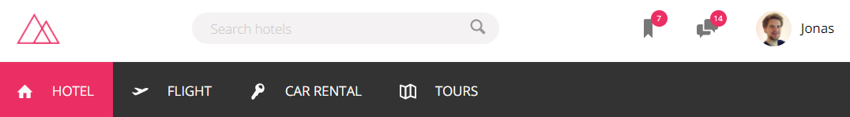

What we want to happen when we shrink the page enough that the content can no longer fit without overflowing the header is to have the Search-bar appear beloow the logo by allowing the header parent to flex-wrap:wrap; the content when it starts overflowing. With the default order of items as they appear in the header the first element to get wrapped into a new line would be the **Jonas user name and image**.

In order to have the search-bar appear as the first element to get wrapped into the next line we have to place it as the last element in the header-flexbox. To do this, we have to give it a larger **order property value** than its sibling flex elements. How **order works is the element with the largest number value appears as the last element in the flex-container**

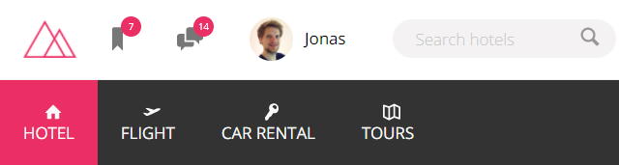

In the image above we can see that the search bar is now the last element in the header-flex container

.search-bar {

  @media only screen and (max-width: $bp-small) {

    order: 1; //placing the element on the last position in the row

flex-basis:100%;//make it take up the entire width of the flex container.

  }

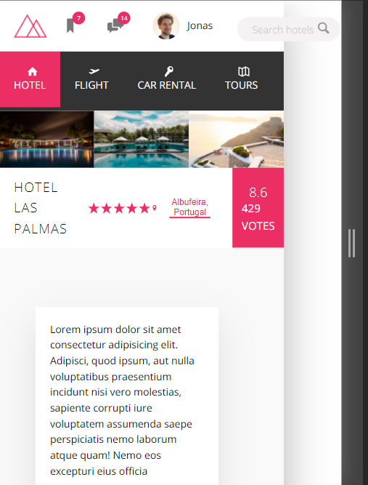Now for it to wrap into a new line when it starts overflowing the parent element(when the browser window becomes really small /think smartphone width) we have to give the parent **flex-wrap:wrap;** property, or else all of the elements will maintain their position in the row, regardless of how much they are overflowing the heaer-flex-parent. As we can see in the adjacent image.

.header-flexbox {

  display: flex;

  justify-content: space-between; //horiznotally align

  align-items: center;

  flex-wrap: wrap;

}

This problem dissappears when we implement the flex-wrap:wrap property value.As the overflowing content gets wrapped into a new line in the order it appears In the flex-row.



.search {

  //Flex item properties

  flex: 0 0 40%; //noGrow NoShrink 40%Baseline

  //Flex-container property

  display: flex;

  align-items: center;

  justify-content: center;

  @media only screen and (max-width: $bp-smallest) {

    order: 1; //placing the element on the last position in the row

    flex-grow: 0;

    flex-shrink: 0;

    flex-basis: 100%; //make it take up the entire width of the flex container.

  }

Solving the spacing issue between the search-box and the other flex-elements, now that the flex-container wrapped the search box into a new line.

For this purpose align-items won’t take any effect, since it only works on single line flexboxes. For multiline flexbox we simply use **align-content: center/space-around/space-between;**

header {

  _||_ …

  @media only screen and (max-width: $bp-smallest) {

    //breakpoint at 500px

    flex-wrap: wrap;

    height: 12rem;

    align-content: space-around;

    //multiline flex elements can get aligned only using

    //align-content

  }

}



And here we can see the effect taking place, making space between the main flex row and the new wrapped one.

## Using Align-content to align multi-line flex elements

[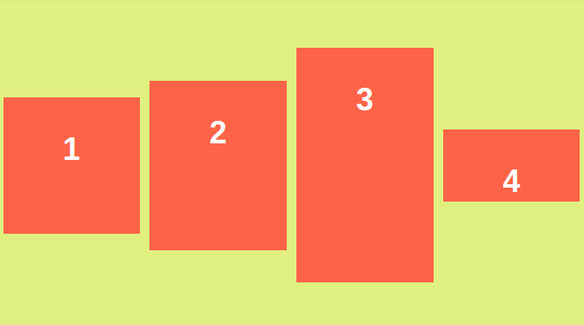](https://i.stack.imgur.com/Wcfm5.png)The **align-items** property of flex-box aligns the items inside a flex container along the cross axis just like justify-content does along the main axis. (For the default flex-direction: row the cross axis corresponds to vertical and the main axis corresponds to horizontal. With flex-direction: column those two are interchanged respectively).

Here's an example of how align-items:center looks:

[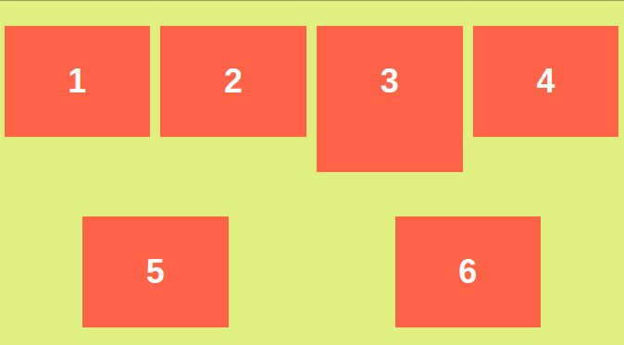](https://i.stack.imgur.com/OHTV1.png)

**But align-content is for multi line flexible boxes. It has no effect when items are in a single line**.

It aligns the whole structure according to its value. Here's an example for align-content: spacearound;:

[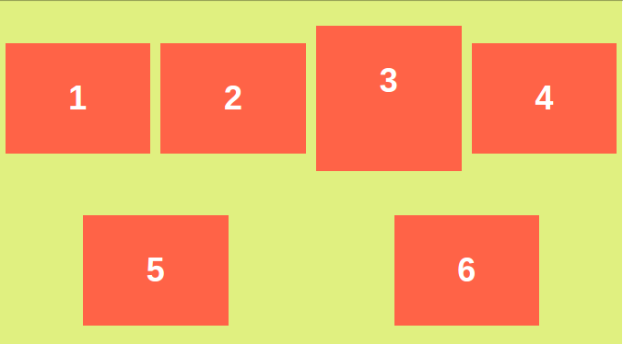](https://i.stack.imgur.com/qX3as.png)And here's how align-content: space-around; with align-

items:center looks:

Note the 3rd box and all other boxes in first line change to vertically centered in that line.

## **Visiblity(hidden) vs Display(none) properties**

**visibility:hidden** hides the element, but it still takes up space in the layout.

**display:none** removes the element from the document. It does not take up any space.

## TRILLO CHALLENGES

# **CSS GRID**

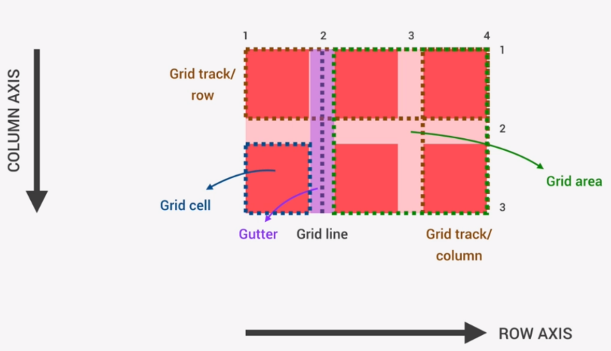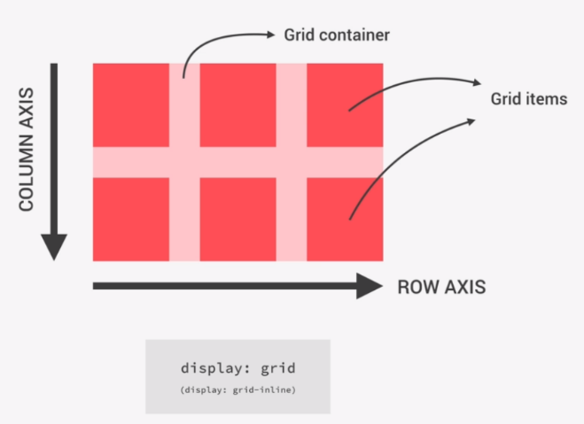

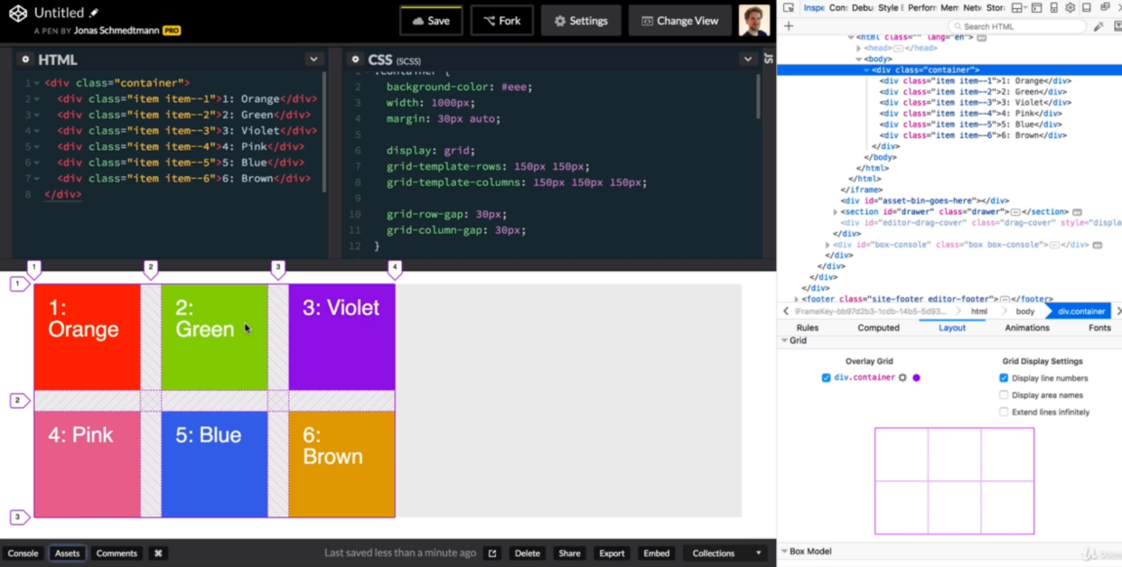

Note that when we use percentages to define widths of our tracks (column-track/column-row) the grid basically makes the track the entire percentage of the grid, So in this case 50% for the first column-track means that the column-track is 50% of the width of the entire grid, and the rest 50% of the other track elements are divided by the relative fr sizes of the remaining 50%, which includes the gutter space between the columns. So 50% is the width of the first column-track (without the gutter) and the second 50% contains the two gutters, and two more column-tracks of which the first takes up two fractions and the second one fraction of the remaining space.

So the fraction works as the proportion of remaining space. If three elements have a fraction of 1, it means they will all take up the same proportion when taking up the entire remaining space.

If three elements have fractions: 1, 2, 4 then the first element will be twice smaller than the second, and second two times smaller than the third, but together they will take up the entire available space.

With this in mind, a single element size defined in a fraction of (1) will always take up ALL available space.

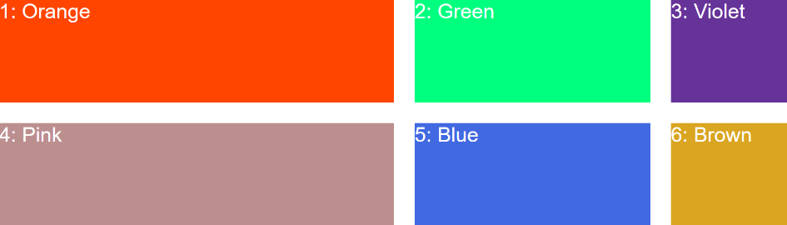

grid-template-rows: repeat(2, 150px);

grid-template-columns: 50% 2fr 1fr;

# PROJECT NEXTER (CSS – GRID)

## **Building the overall layout of the CSS grid Project**

### **Creating Component elements without the parent component**

It is perfectly legal to create component-elements (__doubleUnderscore) even if there is not a defined parent to the components. The fact that the elements share a common Component name before the underscores, denotes that they are in fact parts of a single component (even if that component is not a parent element)

**Story component**

div class="story__pictures">Story pictures</div>

<div class="story__content">Story content</div>

As we can see, the story component will not have a parent **.story** element, but is instead just comprised out of the un-nested individual components.

To repeat **It is legal to create component elements without a defined common parent component**

### **Using the BODY element as the OVERALL page GRID-CONTAINER**

<body class="container">

<div class="sidebar">Sidebar</div>

<header class="header">Header</header>

<div class="realtors">Top 3 realtors</div>

<div class="section features">Features</div>

<div class="story__pictures">Story pictures</div>

<div class="story__content">Story content</div>

<section class="homes">Homes</section>

<div class="section gallery">Gallery</div>

<div class="footer">Footer</div>

</body>

All of our sections will be placed inside GRID ROWS, so for each section of the page, we create a new Grid-row.

To make the first div.-row wonderfully responsive, we will be using VH(viewport-height) units, when defining their height, so that the rows adapt to wider or narrower viewports, responsively.

**The first row** we want to define strictly in viewport space(viwport height **vh)**

**The second row** we want to have adapting to content (so that it increases/decreases) as the content height gets higher/lower. Remember that in mobile or narrower viewports, your content getting squished vertically means the row would have to increase in order to fit it, and for this to happen grid-template-rows: for the row has to be set to either (auto || min-content)

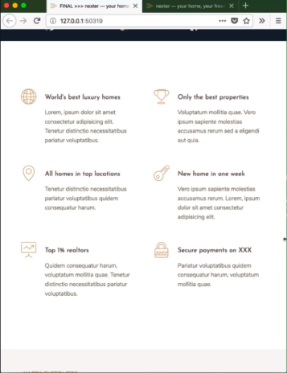🡨 Narrower screen (higher content, wider row)

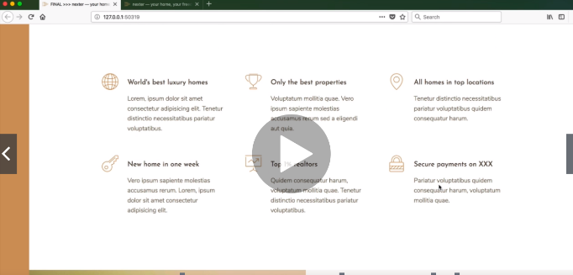

Wider screen, narrower content and hence, narrower row 🡪

**The third row** will be a function of viewport width, so that it will always adapt to the viewport width, so that it will always adapt to the current viewport width.

**It is incredibly important that we think about responsive design right from the beginning by using vw vh units (responsive units relative to the viewport) percentages, and auto/min-content functions, all of which allow us to streamline the responsiveness of our page along the development process.**

### **Auto/min-content ROW-height**

**Note that it is usually a best practice to allow the rows of our LAYOUT GRIDS to adapt their height to the content (much more so than for the columns.** Also, please note that min-content and “auto” basically function the same way in this content.As min-content means: caluclate the box size so that it fits snuggly the content contained within, or in other words the box will minimally cover the content inside it. (add to this some padding and you get the minimal height/width of the container, necessary to contain the elements/content within it). In this regard “min-content” and “auto” function just about the same way.

.container {

  display: grid;

  grid-template-rows: 80vh auto 40vw repeat(3, min-content);

}

By making the initial dimentions of our grid-layout in relative units, especially those relative to the viewport, we don’t even have to bother with media queries, as the layout elements will always take up a consistent proportion/ratio on the screen, and if otherwise stated, make sure to wrap around(fit) the content placed within it. So this way we are very much at an advantage compared to writing dimentions in fixed pixel widths, where we’d have to change the layout dimentions for all relevant devices, using media queries (manually) without getting near the same smooth responsive effect as thinking and setting up relative(hence responsive) container sizes.

## Design grids and the commonly used number of columns

It is very common to see entire webpages being designed in a 8 to 12 column grids (with as many rows as there are page sections). Bootstrap for example, uses a 12 column grid to create the overal layout of the entire webpage, and even if all of these columns may not be necessary for every webpage design, the fact that the 8 to 12column grid is so common, means that it is a good practice to the typical grids, as it makes them familiar and more easily scalable, if you wish to include more elemenets from other designs into your page.

### **Making the 8 column design grid**

We want to make **our entire grid 1140px in width**. With the grid content centered in the middle, and the columns squishing in size as the viewport gets smaller.

* First things first, to make the entire grid our desired size we simply divide the industry standard **1140px** grid-width with the number of columns it contains (**1149/8 = 142.5px)**
* Then we convert the calculated single-column width **142.5px** into rem(10px) 142.5/10= **14.5rem** then we round it to **14rem**

#### **Making the colums responsive in width**

For this, we will once again be using **min-content** value, which forces the browser to stop shrinking the element, below the necessary size to fit the content placed within it. So min-content is the smallest the element can get and still fit the content placed inside it.

To tell the column it should be 142px or 14rem in width, and shrink but not so much that its content overflows, we would use the **minmax()** function where we define the column-size

grid-template-columns: repeat(8, minmax(min-content, 14rem));

So the width of these columns is going to be between the minimum column content and 14rem(140px).

#### **Adding a SIDEBAR column on the left**

grid-template-columns: **8rem** repeat(8, minmax(min-content, 14rem));

we basically just added a new column before our 8columns by writing an explicit value for it **8rem.**

Our complete body .container 🡪 **LAYOUT GRID with named columns**

.container {

  display: grid;

  grid-template-rows: 80vh auto 40vw repeat(3, min-content);

  grid-template-columns:

[sidebar-start] 8rem

[sidebar-end full-start] 1fr

[center-start] repeat(8, *[col-start]* minmax(min-content, 14rem) *[col-end]*)

[center-end] 1fr [full-end];

  grid-auto-columns: min-content;

#### **Centering our 8columns between the sidebar on the left and viewport on the right**

Let’s think about this a bit, so we have 8 columns that we want to center, but 9 columns in total, and we want to center all of the columns, except for the first one, which should stay at the far left.

One way to center or 8columns would be to add a single (whitespace or content devoid) buffer column on each side of the the 8column part of the grid that we’d want to center, whereas each of our buffer columns would need to occupy the remaining horizontal space on the page.

  grid-template-columns: 8rem **1fr** repeat(8, minmax(min-content, 14rem) **1fr**);

Remember that 1fr(fraction) always represents fraction-of-available-space “remaining-space”, so adding two columns each 1fr means, that all available space will be divided between those two columns.

### Centering grids on our webpage

Before we’d use empty columns defined in fractions to fill out the remaining space around our content columns, but centering grids is in fact much more simple than that.

We can do the following to center align a grid:

* **justify-content:center; 🡪** or **flex-start, flex-end**
* **margin: 0 auto; 🡪** or otherwise defined margins to center the grid where we intend to

#### **If centering a grid is so simple, why bother adding additional empty columns?**

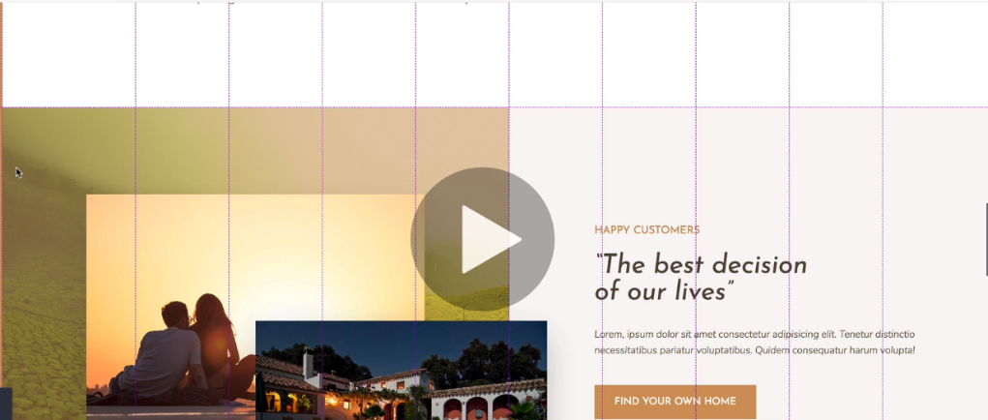Basically adding empty columns allows us to create **full-bleed** sections, which are sections in our webpage that bleed over from our predefined 8column grid into the other two columns, that we’ve added for centering the primary 8 columns.

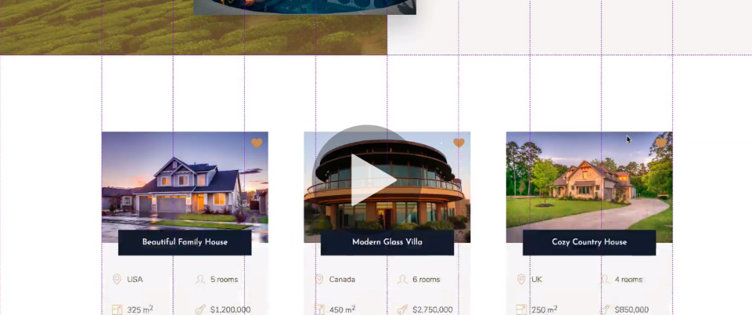

This means that some of our sections actually take up the entire 8main+2side colums while the rest of the website is centered and contained within the main 8 columns.

This way we can have some full-bleed sections in the middle of some 8column sections, as can be seen on the image to the left.

### **Naming our Columns/Rows**

grid-template-rows: 80vh auto 40vw repeat(3, min-content);

  grid-template-columns:

[sidebar-start] 8rem

[sidebar-end full-start] 1fr

[center-start] repeat(8, *[col-start]* minmax(min-content, 14rem) *[col-end]*)

[center-end] 1fr [full-end];

Note that we can name our columns and row lines by placing brackets on before (start-line) and after(end-line) of our row/column template definition

So for a column 8px in size: grid-template-columns: [start-col-line]8px[end-col-line], so what these neames denote is not the name of a column, but of the lines that make up the column.

Since we are naming our column/row lines, it should be remembered that there are always +1 column/row lines than there are columns/rows.

* So two-rows 🡪 3 row-lines
* 3 columns 🡪 4column-lines

## Last-column/row keyword

Since we can tell how many rows/columns our grid-child elements should span, we should be aware that there are a couple of ways we can define the row/column spans.

1. By defining the row/column number **grid-row-start: 1; grid-row-end:2;**
2. By defining the row/column names **grid-row: start-col-line / end-col-line;**
3. By defining a column/row line keyword **grid-row: start-col-line/-1;**

#### **Last EXPLICIT grid/row line keyword (-1)**

**(-1) is the keyword for the last explicitly defined row/column line, regardless of its line-number or line-name, so however many rows/columns we explicitly add, the row/column span will always update to the most current last explicit row/column, if (-1) is defined as a start/end**

## Prioritizing Columns over Rows In GRID layouts

Columns are always more important than rows, and because of that we typically **name** **columns**, but **leave** **rows** **unnamed**. Columns are what we use to define the overall layout, while the rows can even sometimes be left at **min**-**content** or **auto**, so that they are not even sized, and as such grow/shrink to fit content. Where we really arrange our layouts in the **BODY**-**GRID** is relative to our columns. While the rows, are basically only there to separate the individual page sections (as generic **div** containers usually do)

**Example of using our named columns to define the column-span of our sidebar**

.sidebar {

  background-color: $color-primary;

  grid-column: sidebar-start / sidebar-end;

  grid-row: 1/-1; //notice the (-1) denoting the last row on the webpage }

### **Named set of grid lines**

grid-template-columns:repeat(8, *[col-start]* minmax(min-content, 14rem) *[col-end]*);

The above creates a **named-set** of 8 columns, all of which are defined by two lines, their starting [col-start] line and their ending [col-end] line (both of which are freely named by the programmer)

So if we were to for example want one of our elements to span the first and second column we would denote the col-span as follows:

.header {

  grid-column: col-start 1 / col-end 2;

}

This element would start on the starting line of column(1) and end on the ending line of column(2), so it would span the first and second column, respectively.

If we wanted the element to span from the fourth column all the way to the eigth column (including the eight) we would write the following:

.header {

  grid-column: col-start 4 / col-end 8;

}

* Start at the start line of the column 4 🡪 col-start 4
* Stop/end at the ending line of column 8 -🡪 col-end 8

## **BASIC GRID LAYOUT (COMPONENT)**

.container {

  display: grid;

  grid-template-rows: 80vh min-content 40vw repeat(3, min-content);

  grid-template-columns:

    [sidebar-start] 8rem [sidebar-end full-start] minmax(6rem, 1fr) [center-start] repeat(8, *[col-start]* minmax(min-content, 14rem) *[col-end]*)

    [center-end] minmax(6rem, 1fr) [full-end];

  grid-auto-columns: min-content;

  & > * {

    //just for developement purposes

    padding: 40px;

    font-size: 3rem;

  }

}

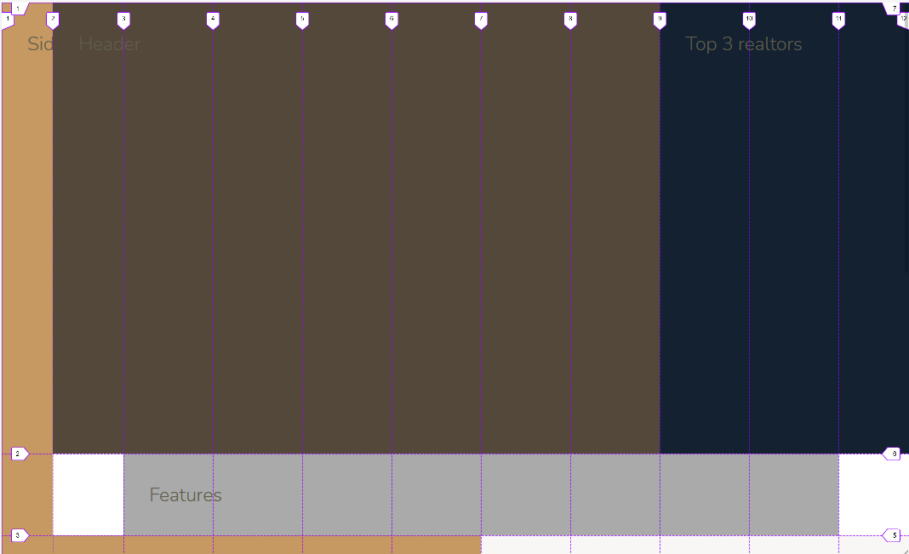.features {

  background-color: $color-grey-light-2;

  grid-column: center-start/center-end;

}

.footer {

  background-color: $color-secondary;

  grid-column: full-start/full-end;

}

.gallery {

  background-color: $color-grey-dark-1;

  grid-column: full-start/full-end;

}

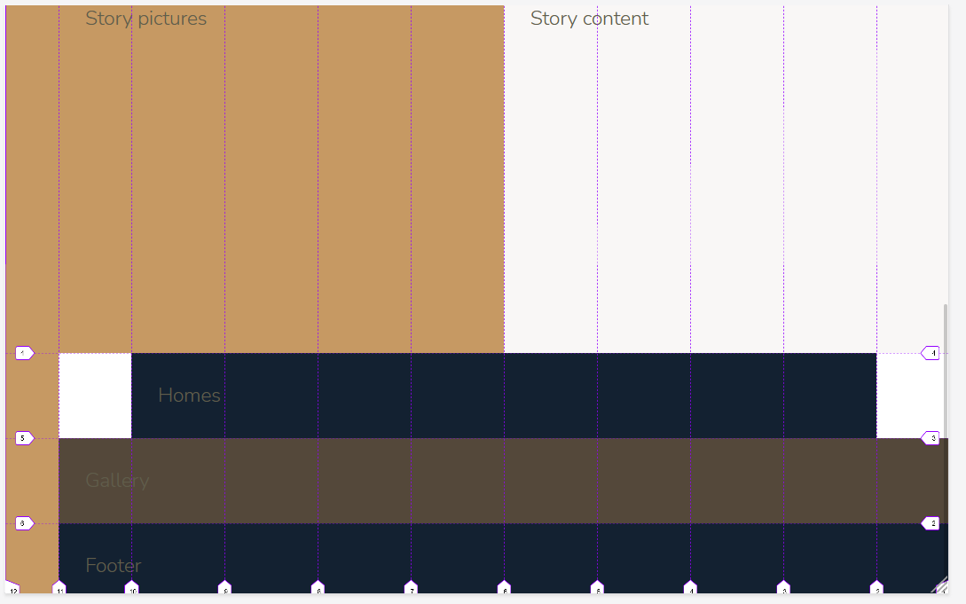

.header {

  background-color: $color-grey-dark-1;

  grid-column: full-start / col-end 6;

}

.homes {

  background-color: $color-secondary;

  grid-column: center-start/center-end;

}

.realtors {

  background-color: $color-secondary;

  grid-column: col-start 7 / full-end;

}

.sidebar {

  background-color: $color-primary;

  grid-column: sidebar-start / sidebar-end;

  grid-row: 1/-1;

}

.story {

  &__pictures {

    background-color: $color-primary;

    grid-column: full-start / col-end 4;

  }

  &__content {

    background-color: $color-grey-light-1;

    grid-column: col-start 5 / full-end;

  }

}

### **Preventing our (1fr) side columns from squishing**

### 

What happens sometimes is that the viewport is so small, the columns set to fractions (1fr) will get narrower and narrower if there is no content to prevent them from shrinking further, as the viewport gets smaller

  grid-template-columns:

[sidebar-start] 8rem

[sidebar-end full-start] **1fr**

[center-start] repeat(8, *[col-start]* minmax(min-content, 14rem) *[col-end]*)

[center-end] **1fr** [full-end];

On the top image we can see that the white columns whose size is set to (1fr) basicalyl get narrower and narrower until almost completely dissappearing. Since we always want to have some margin between the edges of our screen and our content, this is not ideal. So to prevent this from happening we have to define the min value for our **1fr side columns**.

 grid-template-columns:

    [sidebar-start] 8rem

[sidebar-end full-start] **minmax(6rem, 1fr)**

[center-start] repeat(8, *[col-start]* minmax(min-content, 14rem) *[col-end]*)

    [center-end] **minmax(6rem, 1fr)** [full-end];

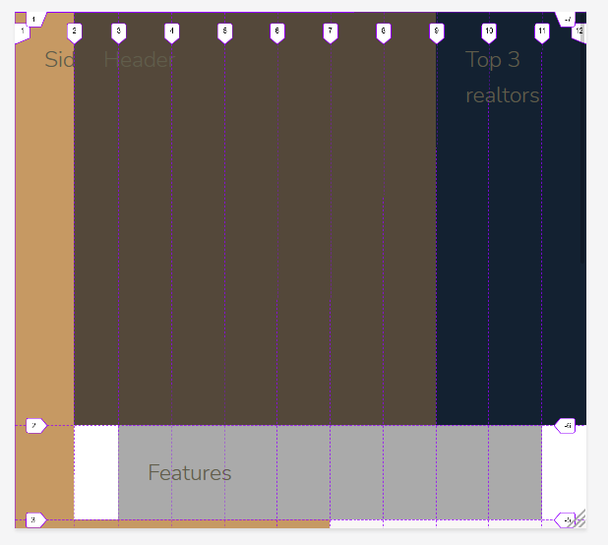And now however narrow our screen gets the side-columns will always be at least 6rem wide and thus prevented from getting squished.

This means that what will continue shrinking is the content colums themselves, and not the side columns.

### Specifying and numbering element dummy text using emmet

 <section class="features">

        .features{feature $}*6 🡪 Turns into the six divs below

      <div class="feature">feature 1</div>

      <div class="feature">feature 2</div>

      <div class="feature">feature 3</div>

      <div class="feature">feature 4</div>

      <div class="feature">feature 5</div>

      <div class="feature">feature 6</div>

    </section>

### **Creating implicit grids by defining only columns**

display: grid;

  grid-template-columns: repeat(3, 1fr);

If we define the number of columns our grid will take up, then rows will be implicitly created for each (colum+1)th element.

So in the case above, (3+1) on every 3+1 elements a new row will be introduced so:

3 elements (one row) 3 + 1 (second row gets created automatically)

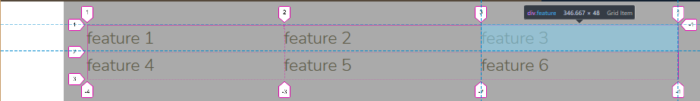6 elements (two full rows) 6 + 1 (third row gets created automatically) and so on…

Note that dotted row lines are dennoting implicitly created rows

## SASS @extend in practice

%heading {

  font-family: $font-display;

  font-weight: 400;

}

.heading-1 {

  @extend %heading;

}

.heading-2 {

  @extend %heading;

}

.heading-3 {

  @extend %heading;

}

.heading-4 {

  @extend %heading;

}

How this works is the placeholder %heading; can extend to all of the selectors where we call it, so the above example in practice works just the same as if we’d have written:

heading-1,

heading-2,

heading-3,

heading-4{

  font-family: $font-display;

  font-weight: 400;

}

So %heading{…} @extend(s) into: heading-1,

heading-2,

heading-3,

heading-4{…}

## **Legality of using transform properties to make slight persistent alterations to our elements**

&__icon {

    fill: $color-primary;

    width: 4.5rem;

    height: 4.5rem;

    grid-row: 1 / span 2;

    transform: translateY(-1rem);

  }

If we just want to slightly adjust our elements, it is perfectly legal to utilize the transform property just for that. Only note that we should of course make sure that it is in that case actually easier to use any of the transform property functions, than other available methods of adjusting our elements, like margins/padding/position, justify OR align and similar…

### Using a grid layout to align a container content

Here we have a 2*2 grid, and three different html elements <svg>,<p>,<h4>

By default the agrid/algorithm will place the elements following the order they were written in html in the 1st, 2nd,3rd,nth grid cell 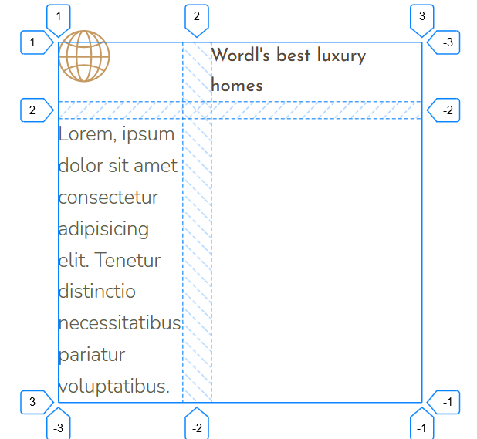respectively.

In this case though, that is not ideal, as we don’t want our text to be squished as it is below the icon, instead we want it to be under the heading, and the icon in line with the heading.

We can do one of two things here. We can either set the text into the second column of the second row, or we can make the icon span two row-tracks, remaining in the same column-track

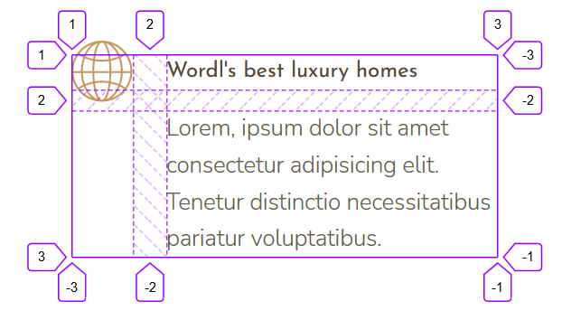Which is exactly what we did to get the desired result here, so by setting the <svg> icon two span two rows, we did not stretch the element, but we did re-arange the allocation of element space within the grid, and the end result was achieved as can be seen.

 &__icon {

    grid-row: 1 / span 2;

    transform: translateY(-1rem);

  }

### **The grid 🡪 align-item property for aligning grid items within their cell**

Align items is the property that controls the alignment of grid items along grid cells. Align-items is by default set to **stretch**, which forces the grid item to fully cover the trid cell.

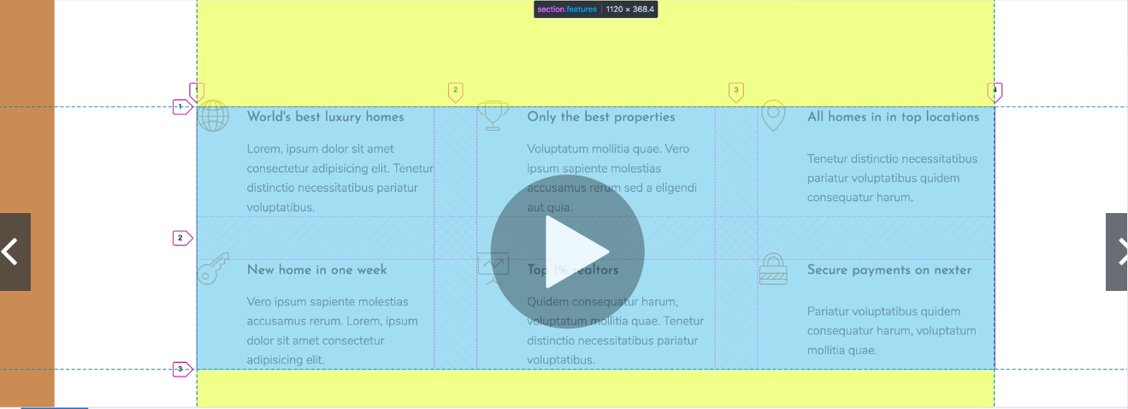

Here, align items is set to stretch

**Align-item** property values and their effects:

* **Center** will move the cell content into the cell-center;
* **Stretch** will make the cell content fit (stretch over) the entire cell
* **End** will make the cell content move to the bottom of the cell (if there is extra cell space for it to move)
* **Start** will make the cell content move to the top of the cell (if there is extra cell space for it to move there)

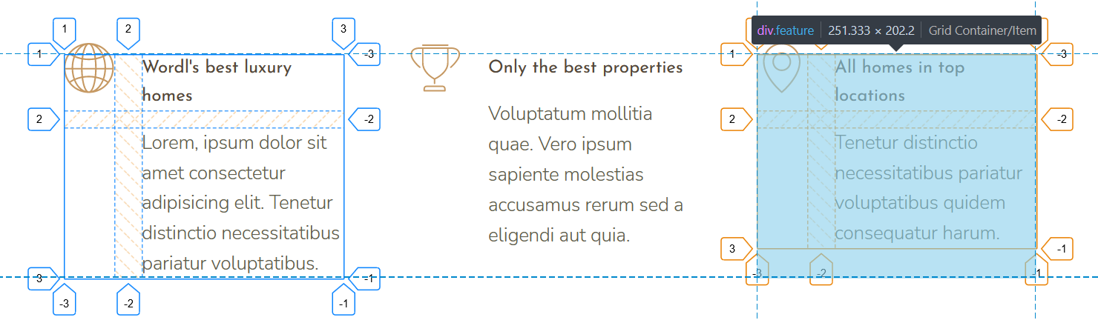

We can see that when shrinking our elements, it becomes much more obvious why we’d want our cell content to remain fixed to the top of the cell, when the cell gets narrower and creates more empty space (notice how the right element ends before the cell it is contained in ends (blue overlay)

## **Creating Responsive-Grids (without using @media queries)**

To make this happen we have to define column tracks, so that they use the **auto-fit** keyword.

### **Auto-fit keyworkd:**

What it does is fit as many elements (rows/columns) of the defined size, as can fit on the current viewport.

.features {

grid-column: center-start/center-end;

  margin: 15rem 0;

  display: grid;

  // grid-template-columns: repeat(3, 1fr); 🡪 old non-responsive grid

**grid-template-columns: repeat(*auto-fit*, minmax(25rem, 1fr));** 🡪 responsive grid

Based on this, css will add as many column tracks of the defined size 🡪 **minmax(25rem, 1fr)** as can currently fit on screen.

To be more specific, on the largest screens, our elements will each take up a fraction of the space (filling up all of the available space on screen and dividing it between the elements (each takes an equal fraction of available space) 1fr

If the viewport gets smaller, our elements will shrink down to 25rem and no lower, then as many of them will be displayed on screen as can currently fit(both on this size and all sizes up to 1fr)

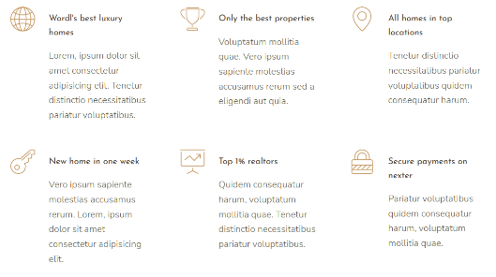🡨On the widest display our elements fit on two rows following their min size of 25 rem

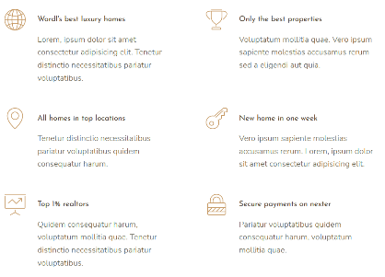 On a narrower display, three columns can no longer fit, as they are all 25rem in width, and can shrink no lower than that, the **auto-fit** keyword moves the column that will not fit into a new row, where it can display with a width of 25rem or 1fr 🡪

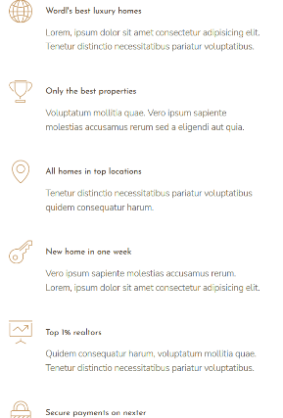🡨On the narrowest screens only a single column can succesfully display, and since our minmax(25rem, 1fr) is set to a fractional unit as well as a fixed rem unit, this means that the single column rows will display over the entire available width (1fr) of our most narrow viewports. Thus making this grid layout trully responsive without any need for @media queries.

**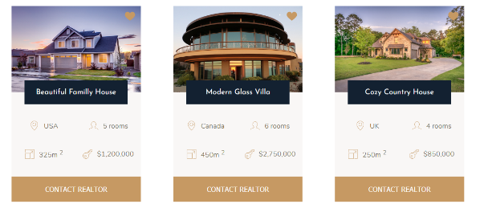*Another example of a responsive grid in action*:**

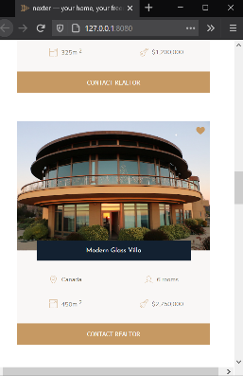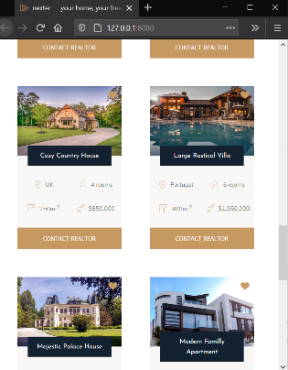

### **Using css sub-grid for aligning items within a grid cell instead of flexbox**

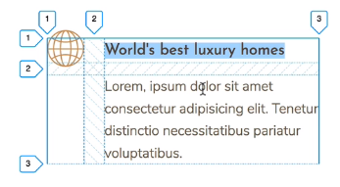

The same effect could be achieved by displaying the cell as a flexbox instead of a grid, but if we were to align the items as flex items, we’d have to add margins or padding to create space between elements here, or add the text into a separate flex container (two nested flex containers inside a grid cell) and use align/justify flex properties there. Compared to that, css-grid is a much more streamlined approach in this case, were you familiar enough to use it well.

Grids can be used as we can see, not just for large layouts, but also for aligning small elements within containers, as long as they are two dimentional (no absolutely positioned elements and such)

## When to create helper classes (utilities)

Basically, sometimes we may create heading elements, or button reusable elements, and in one of our sections we may find that we need that element to have a margin, so it would look and fit better in its current section container.

We could do this by hardcoding some margins into the element (.heading-2{ margin:2rem 5rem;}) for example.

But if our **.heading-2** element is a reusable component, giving the component itself a fixed margin may not be the best idea, as the margin will look great in some circumstances, and terrible in others.

As a rule of thumb do not add margins to your component elements, as you’d want them to appear (As is) whenever you place them anywhere in your website.

How do we then add that much needed margin-bottom of 2rem for a heading in .section1 and the margin-top/margin-bottom: 4rem in .section-2 and .section-3? (hypothetical sections, mind you…)

**The solution is that we use helper classes that we directly add to the class list in our html**

This way the component itself never comes with a built-in margin, and we can easily change the margins for each situation that this single component (or other independen reusable component) gets reused.

#### Concept of Atomic CSS

This concept is directly tied to the idea of helper classes, and is represented by developers styling complete webpages by adding only helper classes to html elements, so by basically it leans on creating or dowloading a framework of helper classes, then applying those classes directly into html elements.

 <div class="story__content">

      <h3 class="heading-3 mb-sm">Happy Customers</h3>

      <h2 class="heading-2 heading-2--dark mb-md">&ldquo;The best decision of our lives&rdquo;</h2>

      <p class="story__text">

        Lorem, ipsum dolor sit amet consectetur adipisicing elit. Tenetur distinctio necessitatibus pariatur voluptatibus. Quidem consequatur harum

        volupta!

      </p>

      <button class="btn">Find your own home</button>

    </div>

Note how the **story_text**  did not get a helper class margin (mb-sm or mb-lg), and this is because helper classes should only be added to reusabloe components, and the **story__text** is a specialized component that only makes sense in the **.story** section and can be used nowhere else. (so for this component, we’d be adding a margin directly in its class css)

## **Using flexbox vs using a grid to style 1dimentional element content**

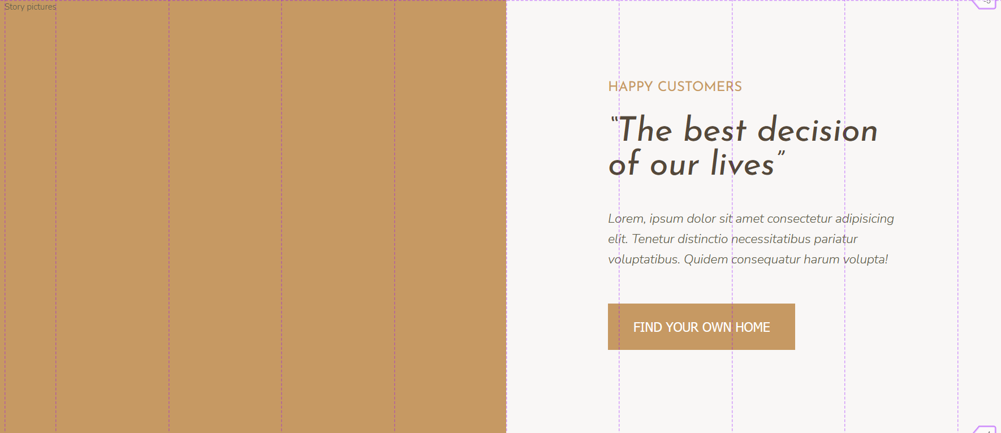

Since all of our content elements in this grid-cell are stacked one on top of each other, we can use flexbox to style the elements and we can also use css grid to style the elements, so lets look at the two approaches.

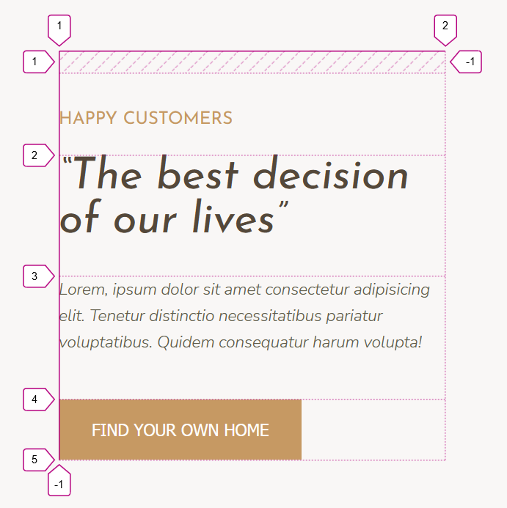**CSS grid:**

&__content {

    display: grid;

    align-content: center;

    justify-items: start;

}

Remembering that

* **Align-content 🡪 aligns on the column axis**
* **Justify-content 🡪 aligns on the row axis**

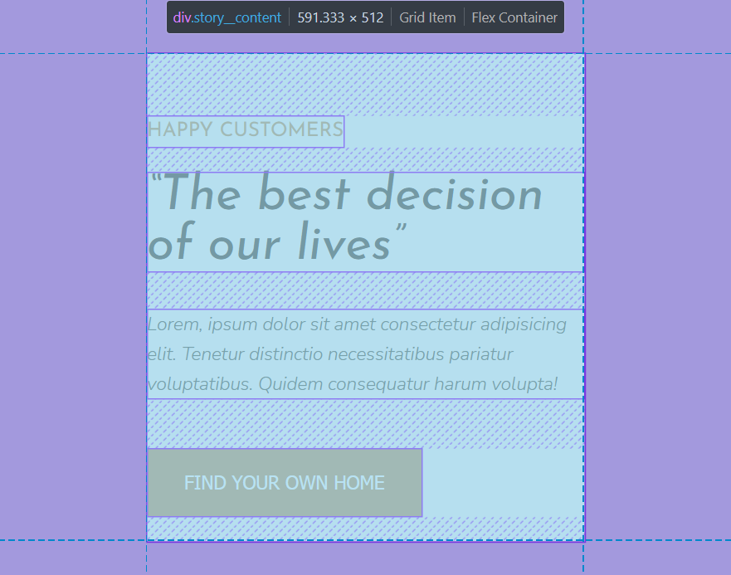&__content {

  display: flex;

    flex-direction: column;

    justify-content: center;

    align-items: flex-start;

}

## Using (vh) and (vw) relative viewport units to make our webpage responsive from the get-go

One of the best ways to make sections of our webpage responsive from the beginning is to use viewport-relative units. So whenever you are setting a margin or a padding to a section, or feel like you should use a percentage(%) it is a best practice to simply use (**vh** or **vw**) instead.

The big takeaway is to replace (%) with (vh) or (vw), everywhere, and use (vh || vw) wherever else it makes sense.

### Flexible images (REVISITED)

Remember that we always define the width of our images in percentages so that they can remain flexible (responsive) and relative to their parent container and not their original aspect-ratio.

Also, by defining just their width, or alternatively just their height, we maintain the proportion(aspect ratio) of the image.

&__img--1{

    width:100%;

  }

  &__img--2{

    width:100%

  }

### Fitting an image within a grid

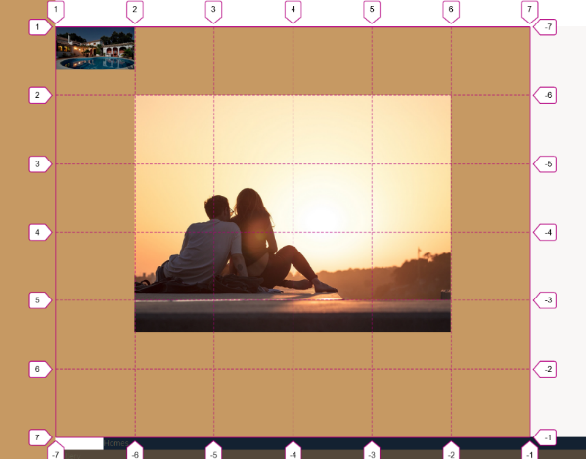

In this example we wanted to center an image within a 6*6 container, so that there is one row left on the top and bottom, and one column on each side

 &__img--1 {

    width: 100%;

    grid-row: 2 / span 4;

    grid- column: 2 / span 4;

  }

Below is the parent container (row-track, column-track) definition.

.img-container{

display: grid;

    grid-template-rows: repeat(6, 1fr); //Creating 6 equaly sized rows

    grid-template-columns: repeat(6, 1fr); //creating 6 equally sized column containers

  }

The problem with aligning images along row/column tracks is that the images by default tend to maintain (keep) their original aspect ratio and so, they will stretch out to fill the row/column tracks only as far as they get to maintain that aspect ratio.

**In other words, the images zoom, but do not stretch**

**While any other, element, positioned thusly would stretch out to fill all of the colum/track cells it spans.** 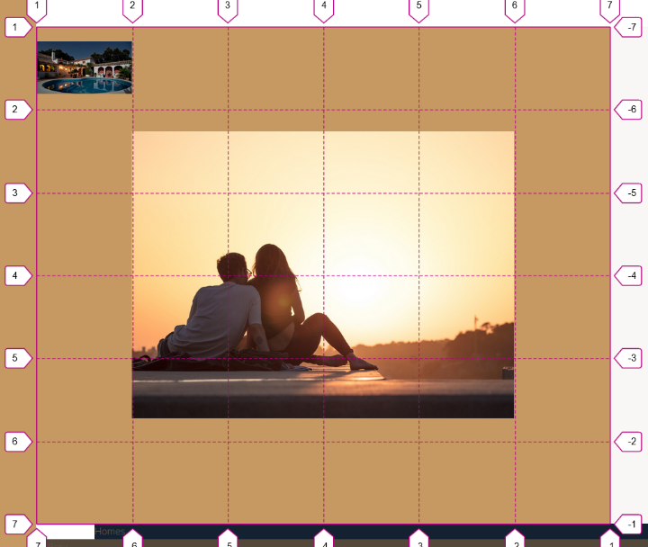How then do we center the image if it will not completely fill the row/column track?

Simply check if the image is not filling width of a cell or the height of a cell? If it does not fill a the width of a cell track, then use **justify-content** to center it along the row axis (since columns left right space is the row axis). If the image does not fill the height of a cell, like in the above example, then we use **align-items** to center the image relative to the column axis (top/bottom of the cell).

 &__img--1 {

    width: 100%;

    grid-row: 2 / span 4;

    grid- column: 2 / span 4;

align-items: center;

  }

## **Creating the overlapping image**

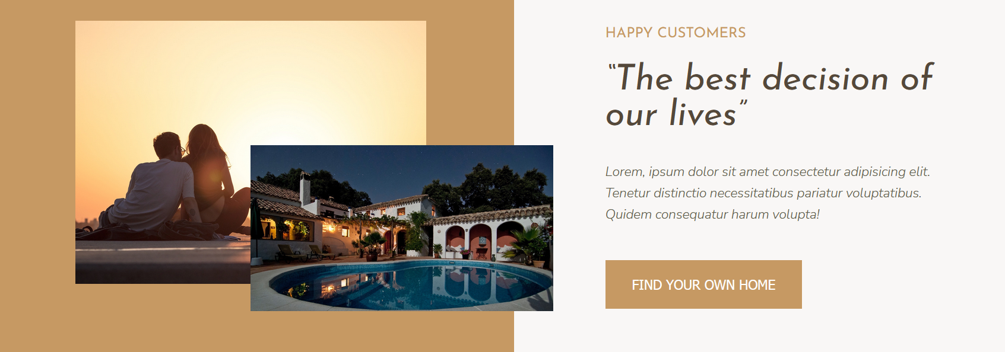

The idea here is to have both images aligned to the center of their cells, then to place second image to the low-right corner of the center image, with the top left corner of the bottom image, in the center of the main picture.

To do this we simply set the image to the columns and rows at the center line intersection of our center image

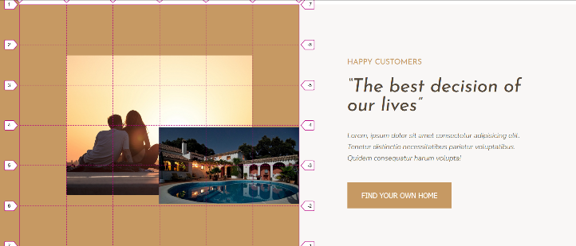 Now our images have their width set to 100% of their parent container. So of course, the image as it stands right now, will not overflow the parent container. But we do want it to overlap into the content section on the right. There are a few ways we can do this. Scale the image up or translate it to the right (but remember that we want the left corner of the image to maintain itself in the center of the main picture. So scaling the image is a much better choice, though we’d have to use **transform-origin** property (top/left) to make sure the image scales from the left upper corner down.

The other. Way simpler way to do this is to set the image width to **115%;** 🡪 and it will automatically overflow outisde of the bounds of its container, while it’s left top corner remains centered on the main image. So this is a perfect solution to our problem.

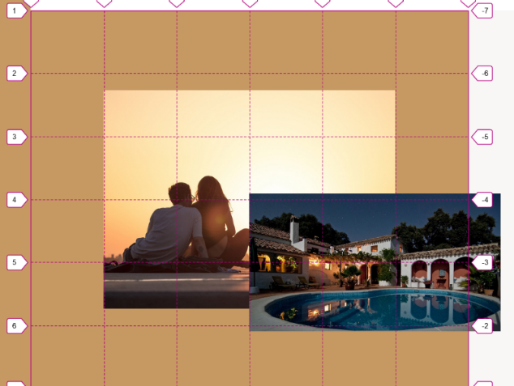Just note that for the image to be visibly out of the bounds of the parent rectangle, its z-index should be higher than that of the background elements.

 &__img--2 {

    position: relative;

    z-index: 20;

    width: 115%;

    grid-row: 4 / span 2;

    grid-column: 4 / 7;

  }

### Styling the background using the linear-gradient background-image trick

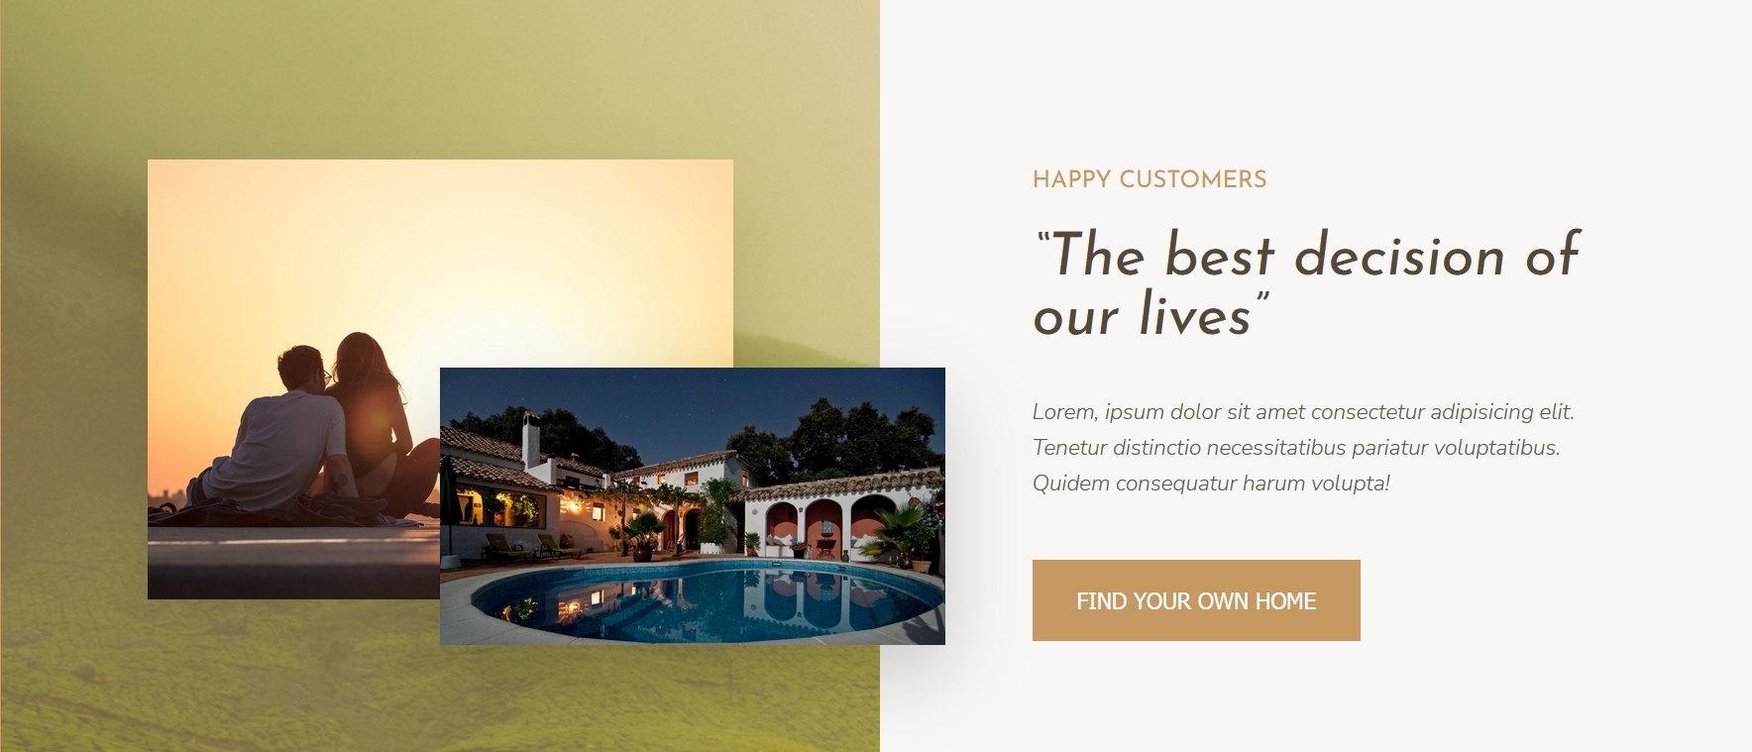

To have the background image on the left container of the section fit in better with the overal color scheme, we add a semi transparent background overlay using a linear gradient, to the backround image property. (we are adding a linear gradient, because the only way we can make the background-image property accept a color value is to set the color inside a linear gradient function)

 &__pictures {

    grid-column: full-start / col-end 4;

    background-color: $color-primary;

    background-image: linear-gradient(rgba($color-primary, 0.5), rgba($color-primary, 0.5)), url(*../img/back.jpg*);

    display: grid;

    grid-template-rows: repeat(6, 1fr); //Creating 6 equaly sized rows

    grid-template-columns: repeat(6, 1fr); //creating 6 equally sized column containers

    align-items: center;

  }

Setting two gradient colors of the same value and transparentcy in a linear gradient function results in a single color overlay (without the gradient effect) which is exactly what we want.

### How to build a complext component using a mix of CSS Grid properties, overlapping and flexbox (COMPONENT)

### 

#### Creating the overall Layout-grid for the section

.homes {

  grid-column: center-start/center-end;

  margin: 15rem 0;

  display: grid;

  grid-template-columns: repeat(*auto-fit*, minmax(25rem, 1fr));

  grid-gap: 7rem;

}

//the browser will automatically fit as many columns as can (auto-fit) into a row

//the columns will all take up at least25rem(250px),shrinking no more, and otherwise

//on large screens each column will take up an equal fraction of the entire available //row space (1fr)

//Gap between the elements will be 7rem(70px)

.home {

  background-color: $color-grey-light-1;

}

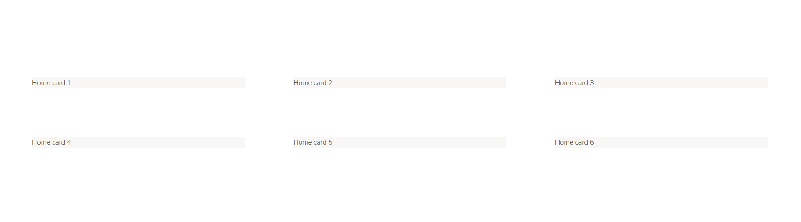

### 

#### Placing the heart icon over the image (Grid overlapping)

Note that when we want to place elements on top of each other in a shared grid-cell, we have to specify both the **grid-row** and **grid-column** for both item, otherwise the automatic grid placement algorithm will by default make empty space within the cell for the other element. (in other words, by default and unless both the columns and rows for both elements are specified for the same shared cells, the grid algorithm does not allow overlaping).

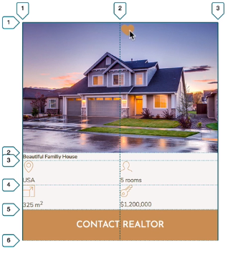&__img {

    width: 100%;

    grid-row: 1/2;

    grid-column: 1 /-1;

  }

  &__heart-icon {

    grid-row: 1/2;

    grid-column: 2/3;

    justify-content: end;

    align-items: end;

    height: 2.5rem;

    width: 2.5rem;

    display: absolute;

  }

Note how both the image and the overlaping heart-icon have to have explicitly defined grid-row and grid-column properties.

#### Supscript tag

The <**sup**> **tag** defines superscript text 🡪 m2 🡪The text at the top of a character

### Grid-align-self and justify-self

 &__estate-name {

    grid-column: 1/ -1;

    grid-row: 1/2;

    justify-self: center;

    align-self: end;

  }

Justify-self; aligns the item in the grid on the horizontal axis (left/right)

While the align-self does it in the vertical axis (up/down)

### Making the real-estate name overlap over the bottom of the image

Basically, by now we are used to not having to use absolute positioning for features like this, now that we can use the transform property functions like scale(_) and translate()

So in this example we will simply use the defined position of the estate name, and translate it in the Y axis down over the image bottom and into the white section.

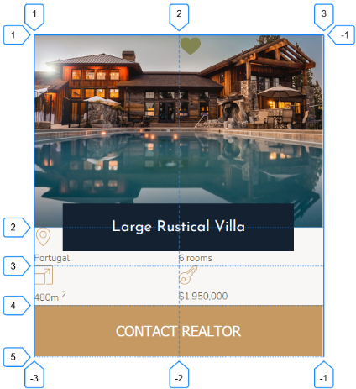Now we want our estate-name to be placed exactly on its Y-axis vertical center, between the image and the white space. Since its bottom border is on the exact edge of the bottom of the image, translating the element 50% of its own width (how translate always references the widths own current height/width), will make it overlap exactly halfway (on its vertical center) between the image and the white section

&__name {

    display: relative;

    z-index: 20;

    grid-column: 1/ -1;

    grid-row: 1/2;

    align-self: end;

    justify-self: center;

    width: 80%;

    font-family: $font-display;

    font-size: 1.6rem;

    text-align: center;

    padding: 1.25rem;

    background-color: $color-secondary;

    color: #fff;

    font-weight: 400;

    transform: translateY(50%);

  }

## **Creating an image-gallery**

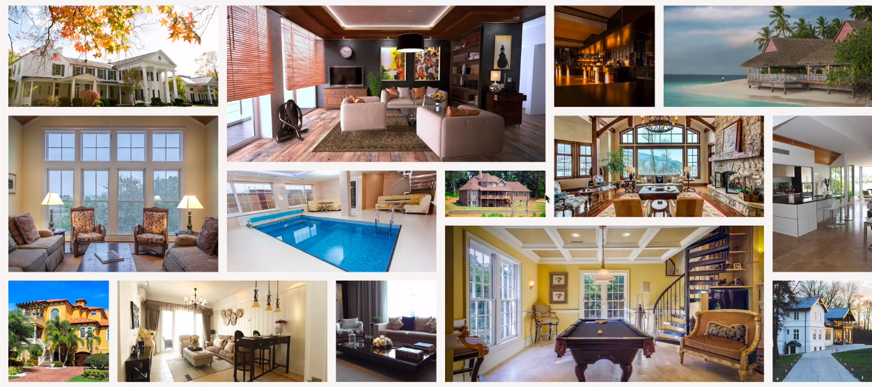

Something to think about, that is crutial to successfully creating a gallery like this is to dettermine the smallest element that you have to fit into the grid.

That smallest element will become your default grid cell size. The smallest image height will be the height of the row, and the smallest image’s width will be the column width of your gallery grid layout.

### **Creating the gallery grid so it is responsive from the start**

The gallery images maintain their aspect ratio, so whenever we shrink the viewport the gallery remains as is, just fitting a smaller screen. So what happens is that as we shrink our viewport, the rows get resized. Now they get resized because we will be defining them in relative viewport widths, so that they display the same way on any device-viewport.

There are two ways of setting this up

1. The first way, is by using the viewport width to define row-height

.gallery {

  grid-column: full-start/full-end;

  display: grid;

  grid-template-columns: repeat(8, 1fr);

  grid-template-rows: repeat(7, 5vh);

}

This means that the rows will always take up 5% of the viewport(screen) and so, scale up and down according to the device they are displayed on, awesome!

The second way is to simply give the entire grid element (the grid-parent-container) a fixed viewport height (100vh) , and then set each of our grid-rows as an equal fraction of their parent container so 🡪  grid-template-rows: repeat(7, 1fr); which would achieve the same result

.gallery {

**height: 35vh;**

  grid-column: full-start/full-end;

  display: grid;

  grid-template-columns: repeat(8, 1fr);

**grid-template-rows: repeat(7, 1fr);** }

In this second case, the entire grid-height will scale relative to the viewport, and the rows will each take up an equal fraction of the total grid-height between them.

While in the first case, the entire grid would scale up/down relative to the individual grid-rows which would always have the relative height of 5% of the current viewport width…

So in the first example the grid height would be relative to the current row height which is relative to the viewport (5% of current viewport *7 🡪 35% viewport height )

While in the second example the row-height would be relative to the grid which is relative to the viewport . (35% of current viewport equaly divided as a fraction of total height 35/7(1fr) 🡪 5%)

## **Using Object-fit to make images fit into grid cells**

As we mentioned earlier, images have an intrinsic aspect-ratio and they tend to always want to maintain it, so when setting an image within a grid, it will scale up or down, but what it will not do is stretch in its height and with in such a way as to change its aspect-ratio.

So what happens is we see the following, even if the images are set to 100% of their parent 🡪 img{width:100%;}

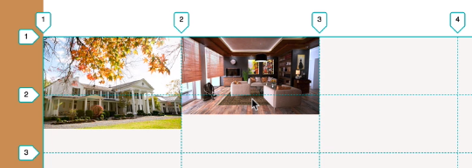

They scale up or down to their individual grid-cell, but since the aspect ratio does not change, in both examples they scaled until either their height or their width fit into the parent, and left the rest to overflow.

This as you can tell is some serious trouble when creating a image-gallery-grid-layout, since we want our Images to fit neatly into the layout we’ve built for them.

The solution is to use the **object-fit:cover;** property, that will force the images out of their intrinsic aspect ratio and clip them to the edges of their current grid-cell.

Now what should be noted is that grid cells do not function as parent containers to an image, so giving an image the object-fit property, without first placing it in a separate parent container, simply will not work.

But having the images in their own separate <div> and that <div> being a grid item (that snaps on to the grid cell bounds), makes the object-fit property, now set the image to **cover** its parent container, that is now defined by the grid column/row tracks.

In short

* give the image a parent <div>) that div should be the grid item representing the image.
* Place that div where you want the image to display on the grid.
* Set the image inside the div to **object-fit:cover;**
* Now your image is displayed exactly where you want it in the grid.

### **Example of using object-fit to snap images into their respective grid-cells**

<!--Start of gallery section-->

    <div class="section gallery">

        <figure class="gallery__item gallery__item--1">

            <img src="img/gal-1.jpeg" alt="gallery image 1" class="gallery__img" />

        </figure>

    </div>

    <!--End of gallery section-->

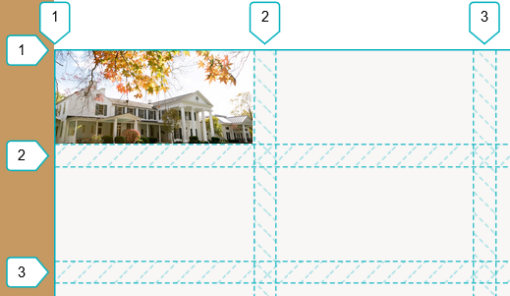

  &__image-container {

  }

  &__img {

    display: block;

    width: 100%;

    height: 100%;

    object-fit: cover;

  }

}

Remember that the object-fit:cover; property has to be applied to the image tag itself, inside its container div. And this property only works if the image is nested inside a separate container <div> or even better <figure> container.

It is very important to define both the **width**  and the **height** of the image, if you want the **object-fit:cover;** to work properly. (usually width/height can be set to 100%), Also remember to set the image to display as a block/inline-block, or otherwise there will be tiny weird white-spaces around the image, since it is usually treated as text and as such has a line-height applied to it.

## **Building the HEADER element**

### 

### The best way to add an overlay to an image(Revisited)

.banner{

background-image: linear-gradient(rgba($color-secondary, 0.93), rgba($color-secondary, 0.93)), url(*../img/hero.jpeg*);

  background-size: cover;

  background-position: center;

}

The best way to add an image overlay is to simply use the **background-image** property and add the background before the image (placing it on top) as a single color gradient with a slight transparency (value in the alpha channel).

Remember to set the background size to cover, and to make sure that the image is not cropped offset relative to its center, simply apply a **background-position:center;** property value (this one is really important, since you’d want most of your background images that are sized set to cover or 100% actually centered relative to the parent container they are a background of.

### **Managing vertical spacing in a responsive layout using CSS Grid techniques;**

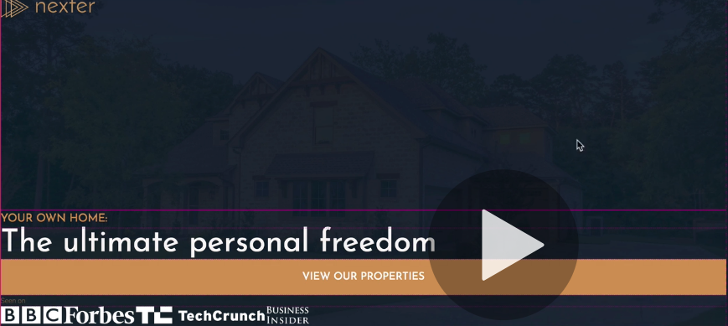

Above we can see the result of giving the first row (1fr) grid-template-row; value, and what it does is assign all available space to the first row, while automatically creating min-content rows for the rest of the elements (since we’ve left them undefined).

Remember that we can use (fr –fractional units) for Rows and Columns,

Remember that this works best when our parent-grid-element has a defined height (in this case 80vw, and yes, you can use viewport widths to define a height of an element)

.grid-contaner{

display: grid;

grid-template-rows: 1fr;

}

The above only defines a signle row height (the first row) and assigns to it all available space sans-min-content of the remaining elements, who get dinamically allocated each a row with the height of min-content.

### **Adding a grid-gap to create (space previously only possible with margins) between our grid rows**

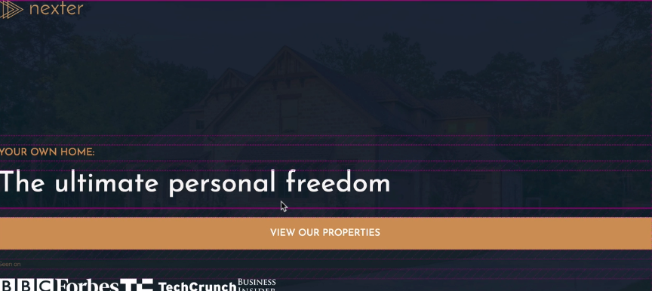

.grid-contaner{

 display: grid;

  grid-template-rows: 1fr min-content 6rem;

  grid-row-gap: 1.5rem;

}

Next we will try to create a lot of space for our button on the bottom, by giving it the same fraction (1fr) of avaliable space as we’ve tgiven to our Logo on top, this means that the button and the logo will now distribute between each other the available space that is now solely occupied by the logo on top.

Unfortunately, as you’ll be able to see, our elements (with a colored background and elements in general, tend to stretch in order to fit the entire cell, so the following result happens

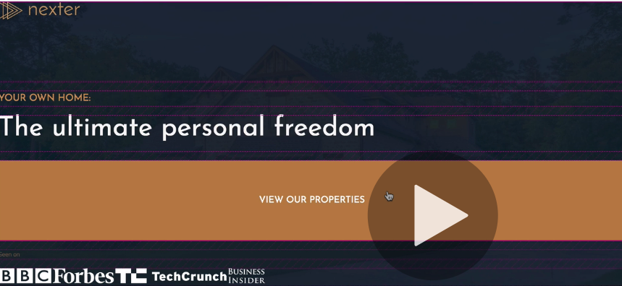

.grid-contaner{

 display: grid;

  grid-template-rows: 1fr min-content 6rem 1fr;

**grid-template-columns: max-content;**

  grid-row-gap: 1.5rem;

}

So the first and fourth row take up an equal fraction of available space between them, the second row takes up min-content (enough height to fit the content) and the third row takes up 6rem of space (to add some space around the content.

Next we will simply make the button element not stretch out to fill the entirety of the row cell🡪

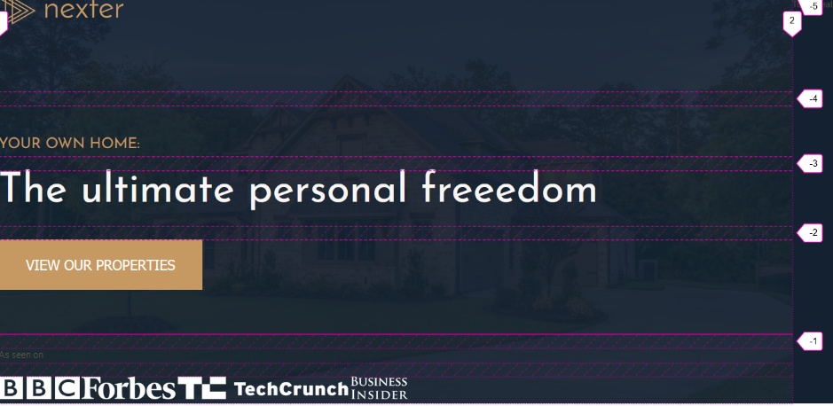

&__btn {

    align-self: start; //it aligns to the top of the cell

    justify-self: start; //aligns it to the left of the cell

  }

Notice how we align the entire grid <ul class=”nav”> to the center of the header by giving the <header class=”header”> element 8rem padding

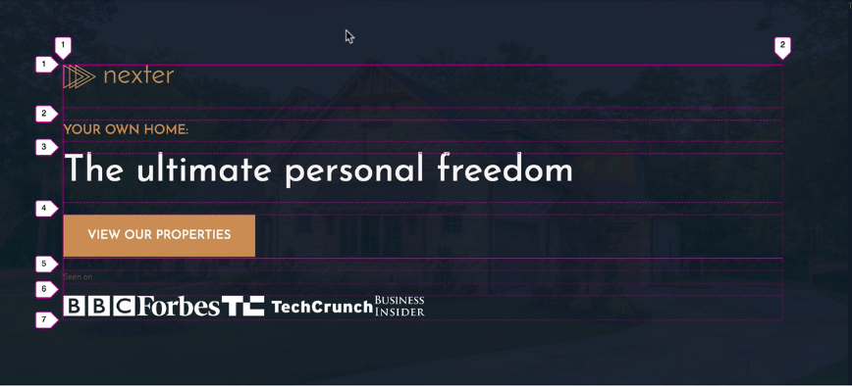

Notice how, while our grid Is indeed centered on the header, the content inside it does not look centered, because there is a lot of empty space to the right, and a lot less empty space to the left.

This happens because the column width is by default 100% of available parent space. And we can make it shrink by setting the grid-template-column to “max-content” so that our single grid column is only as wide as the widest posisible display of the content element contained within it

.grid-contaner{

 display: grid;

  grid-template-rows: 1fr min-content 6rem 1fr;

**grid-template-columns: max-content;**

  grid-row-gap: 1.5rem;

}

### **Why not use min-content to shrink the column, instead of max content**

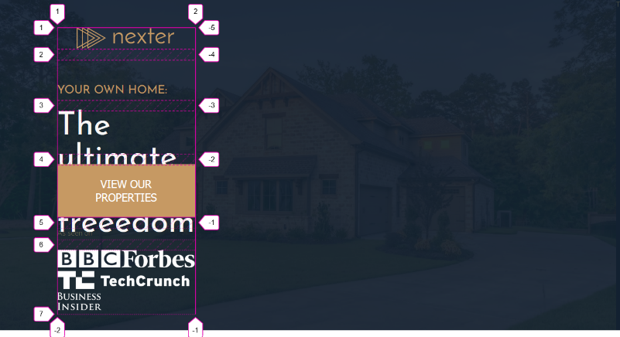Min content represents the minimum possible size that the contained element can take. So if the grid element can shrink further than it is currently displayed, setting the column to min content will inevitably shrink the element until it can shrink no more, and adjust the column size according to that element min-width.

Because of this using **grid-template-column: min-content;** gives us the following result:

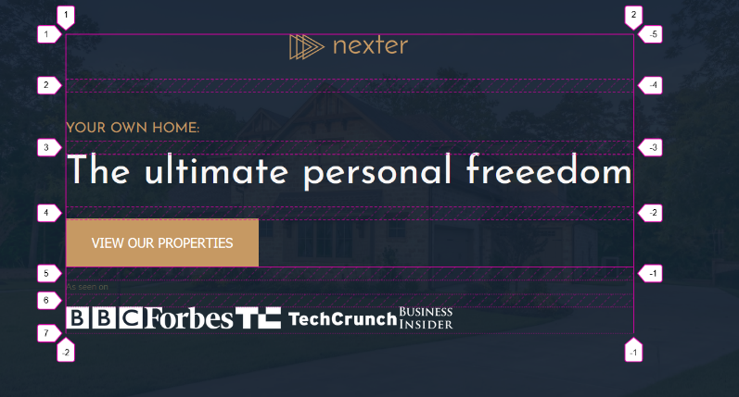

While using **grid-template-column:max-content;** adjusts the column to the maxi-width of the contained content elements and gives us the desired result of adjusting the columns to fit the current max-element-widths as they can display on the viewport, with the following effect:

### **Using inner-text, ::before and ::after pseudo elements as grid items**

Note that grid-containers do not have to have html elements inside them to have a grid element, they can only contain text-content, and that content in itself will be treated as a single grid element. In brief, text content of a Grid-container, will get treated as a separate grid element within that container.

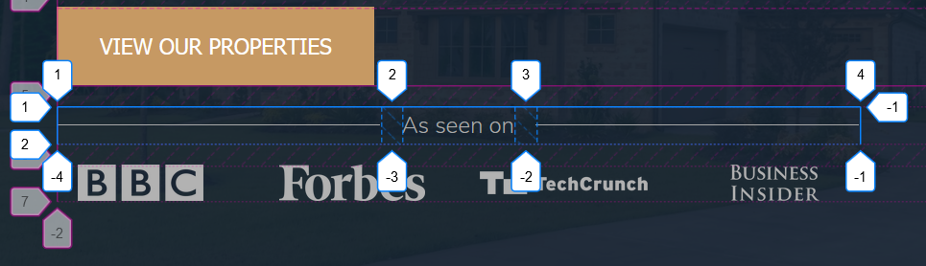Also, apart from text, **pseudo elements are also treated as grid elements**, so in the next example we can see how to style a header portion by using **text, ::before and ::after** pseudo elements, aligning them as grid items:

<div class="header__seenon-text">As seen on</div>

 &__seenon-text {

    display: grid;

    width: 80%;

    grid-template-columns: 1fr max-content 1fr;

    align-items: center;

    grid-column-gap: 1.5rem;

    font-size: 1.6rem;

    color: $color-grey-light-2;

    &::before,

    &::after {

      content: "";

      background: currentColor;

      height: 1px;

      display: block;

    }

  }

### **Making grid columns responsive by giving them minmax() function value**

.container{

display: grid;

  grid-template-rows: 1fr max-content 6rem 1fr;

  grid-row-gap: 1.5rem;

**grid-template-columns: minmax(min-content, max-content);**

}

* Note that the goal here, is to make the column to be as as wide as the max display of the largest contained grid-element within it (if there is enough space for it to fit the screen).
* If there is not enough space for the max-content display of the column, then shrink down until you reach the min-content size of the largest contained grid-element.

Remember that this is not Or/Or, but a scale, it will gradually increase to max-content and no further, and it will otherwise shrink down incrementaly until it reaches min-content and no smaller, so it represents a scale of sizes from the smallest allowed size, to the largest allowed size.

### Fixing the issue of the row height squishing text-content when it wraps text into a new row

What happened here is that the text content was squished and the row height did not change, while the column width did. Since the content now displays on two lines, our row would need to get wider to accommodate.

****To do this, we should remember, what size do our container elements need to have to accommodate squished elements(child items) 🡪 (min-content)

***The previous fixed height for the row of our heading text***

grid-template-rows:  6rem;

***The updated responsive height for the row of our heading text***

grid-template-rows: minmax(6rem, min-content);

Meaning that it is 6 rem usually, but if the content overflows, stretch the row height so that it fits the min-content size of the contained child element

### **Align-content vs Align-items CSS Grid**

The justify-**content** and align-**content** properties **align the grid.**

The justify-**self**, justify-**items**, align-**self**and align-**items**properties **align the grid items.**

* All of this meaning that of course, were you to want to align the grid itself you’d use the the align/justify property on the **content(the entire grid block),**
* and if you want to center or align individual elements within the grid (the grid-elements within the grid cells)then we use justify/align **items**.

### **Changing grid definitions (erasing/adding grid column/row lines) with media queries**

It has to be noted that when you plan to change a grid definition(add/delete rows/columns) you must be very careful to initially name your grid lines. Named grid lines are still referenced by their name even if they change their line numbers.

For example we have three lines (first, second, third)

**grid-template-column: [first-col-start] 1fr [first-col-end scnd-col-start] 1fr [scnd-col-end]**

**first-col-start 🡪 line 1**

**first-col-end/scnd-col-start 🡪 line 2**

**scnd-col-end 🡪 line3**

if we have set up our website components relative to these lines

**.component-1{ grid-column: scnd-col-start/scnd-col-end}**

Even were we to delete the first column, the **.component-1** element would still be positioned where it should be, even though the grid lines have changed

**grid-template-column: [scnd-col-start] 1fr [scnd-col-end]**

**scnd-col-start 🡪 line 1**

**scnd-col-end 🡪 line 2**

**.component-1{ grid-column: scnd-col-start/scnd-col-end} 🡪**Is still on the valid column lines

If we were to alternatively not name our grid column lines, then we would have to update the **grid-column** property definitions for all of our components manually, figuring out what line numbers they should be on if (a column has been deleted) each **grid-column: n(-1);** property value would have to be decreased by one, since one line is missing in the overal grid and all line numbers have been decremented by one, when the row got deleted.

1 2 3 4 5 🡪 deleting the column between 1 and 2 results in 🡪line 1(deleted), line 2(becomes 1), line 3(becomes 2)..line 5 (becomes 4)

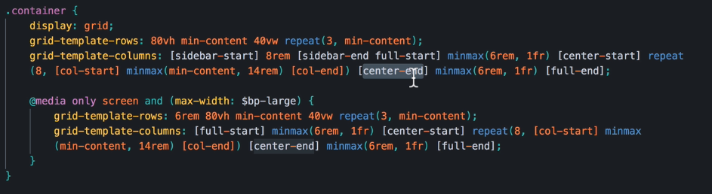

***In summary:***

**Always name your grid column lines if you plan on ever changing the grid definitions using media queries.**

**If you are asigning web-compontents to row lines as well as column lines, then name the row lines as well, so that none of your elements have their positions assigned to line numbers, but dynamically updating line-names, which won’t break the layout as the grid definition changes the line numbers, when a row or column gets deleted or added in the middle of a grid.**

### **Placing the Realtors Header column, as an entire new row of the header**

### 

**Below, changes to the overal grid-layout of the entire webpage**

.container {

  display: grid;

  @media only screen and (max-width: $bp-large) {

    grid-template-rows: 6rem 80vh min-content 40vw repeat(3, min-content);

    grid-template-columns:

      [ full-start] minmax(6rem, 1fr) [center-start] repeat(8, *[col-start]* minmax(min-content, 14rem) *[col-end]*)

      [center-end] minmax(6rem, 1fr) [full-end];

    grid-auto-columns: min-content;

  }

  @media only screen and (max-width: $bp-medium) {

    grid-template-rows: 6rem calc(100vh - 6rem) min-content min-content 40vw repeat(3, min-content);

  }

}

**Below, changes to the specific grid elements (components) inside the overal-grid layout**

.header {

…

…

 @media only screen and (max-width: $bp-medium) {

    grid-column: 1 /-1;

  }

.realtors {

…

…

 @media only screen and (max-width: $bp-medium) {

    grid-column: 1 /-1;

  }

#### **Making our realtors appear side by side in the header**

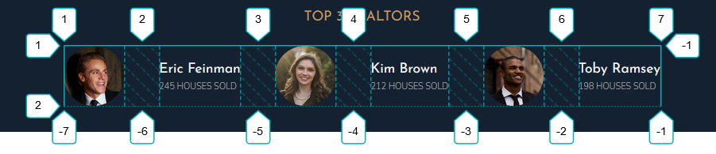

&__list {

    display: grid;

    grid-template-columns: min-content max-content;

    grid-row-gap: 5vh;

    grid-column-gap: 4rem;

    align-items: center;

    @media only screen and (max-width: $bp-medium) {

**grid-template-columns: repeat(3, min-content max-content);**

    }

  }

Note that here we have six columns, odds are images, evens are the details, ti make this happen, we basically had one column with min content(image) and one column with max-content(details text), multiply three times in the **grid-template-columns** property. This is a great example of how the **repeat()** function can take more than one column/row track, as in this case it repeats two column tracks three times, giving us a total of six columns, odds with the min-content width, and evens with the max-content width: grid-template-columns: repeat(3, min-content max-content);

#### **Fitting two Grid elements vertically into our total viewport height (100vh)**

 @media only screen and (max-width: $bp-medium) {

    grid-template-rows: 6rem **calc(100vh - 6rem)** min-content min-content 40vw repeat(3, min-content);

  }

Here we want our header element to fill up all remaining screen space, from the nav-bar to the bottom of the viewport. Now just giving it 100vh will not work, as that means the header will be as tall as the viewport itself, so the entire header space (including the nav-bar) will not fit into the viewport, because the nav bar is 6rem on top of the 100vh.

To make the header element + nav-bar fit together in exactly the space of the entire viewport height, we can use the calc function **calc(100vh - 6rem)**  and make the header element as tall as the entire viewport, sans the nav-bar height. So the header + nav-bar == 100viewport height.

Where the header is (100vh – 6rem) tall, and the nav bar is 6 rem tall

(Worth noting is how we do not have to do a unit conversion to calculate the difference between the element heights when using the **calc();** function.

### 

### Placing the story__pictures and story__content on top of each other

### 

&__pictures {

    grid-column: full-start / col-end 4;

…

…

    @media only screen and (max-width: $bp-medium) {

      grid-column: 1 / -1;

    }

  }

&__content {

    …

…

    display: grid;

    grid-column: col-start 5 / full-end;

    @media only screen and (max-width: $bp-medium) {

      grid-column: 1 / -1;

    }

  }

### At what point do we let the automatic grid assignment algorithm dictate the size of our rows

 @media only screen and (max-width: $bp-medium) {

    grid-template-rows: 6rem calc(100vh - 6rem) min-content min-content min-content repeat(3, min-content);

  }

Above we have an example, where we have 8 row definitions, six of which have their size defined as **min-content.**

Here we should remember that any implicitly created row *(automatically created row for content not fiting inside its current column)* are automatically defined with a default **min-content** size value.

This means that any anywhere we have **min-content** definitions, as long as they are ordered as a continuous set, one after another until the last row definition, the min-content rows will behave the very same way as letting the automatic algorithm assign those rows as implicit rows with the default **min-content** size.

 @media only screen and (max-width: $bp-medium) {

    grid-template-rows: 6rem calc(100vh - 6rem);

// min-content min-content min-content repeat(3, min-content);

  }

As we can see above, commenting out (deleting) the reapeat set of min-content definitions, changes nothing, as the algorithm would have defined those six rows anyway, with the min content value.

Note that we could not delete these definitions, if we had between min-content rows some explicitly defined rows as is shown in the following example

@media only screen and (max-width: $bp-medium) {

    grid-template-rows: 6rem  min-content max-content min-content 100%;

  }

In the above example, deleting the min-content rows, would simply mean that the min-content row would now follow the row definition that superseeds it (the next adjacent one)

: 6rem  min-content max-content;

1st row 🡪 6rem

2nd row 🡪 min-content

3rd row 🡪 max-content

: 6rem  /*min-content*/ max-content; (In this example we comment out the middle row)

1st row 🡪 6rem

2nd row 🡪 max-content *(takes the second defined row definition, in this case the uncommented*

*one, “max-content”)*

3rd row 🡪 max-content *(since there are only two row definitions this one becomes a default*

*min-content implicit row)*

### Defining our **feature-card** elements in a 3*2 grid using floats as well as applying **progressive-enhancement**

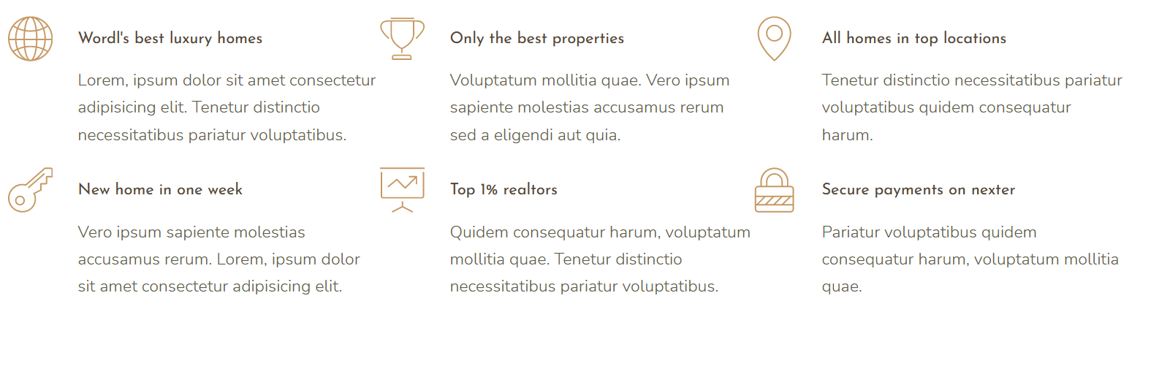

Why are we defining this grid using floats? Well, we are trying to apply the concept of progressive-enhancement, though in all honesty, I just wanted to check out how floats work, since I’m very late to the float-party with all of the flex and grid technologies existing and well implemented four years before I’m writing this.

The idea is to write a **feature-query** that will implement a css-grid-layout if the current browser supports it, otherwise using the above float-grid.

.features {

  grid-column: center-start/center-end;

  margin: 15rem 0;

  @supports (display: grid) {

    display: grid;

    grid-template-columns: repeat(*auto-fit*, minmax(25rem, 1fr)) !important;

    gap: 6rem;

  }

}

//feature is a completely reusable component anywhere else on the page

.feature {

  float: left;

  width: 33.33%;

  margin-bottom: 3rem;

  @supports (display: grid) {

    //use the feature query to reset properties for our css grid to work

    float: none; //note that grid ignores the float property so it is not necessary to reset it

    width: auto;

    margin-bottom: 0;

  }

## Git HUB Crashcourse

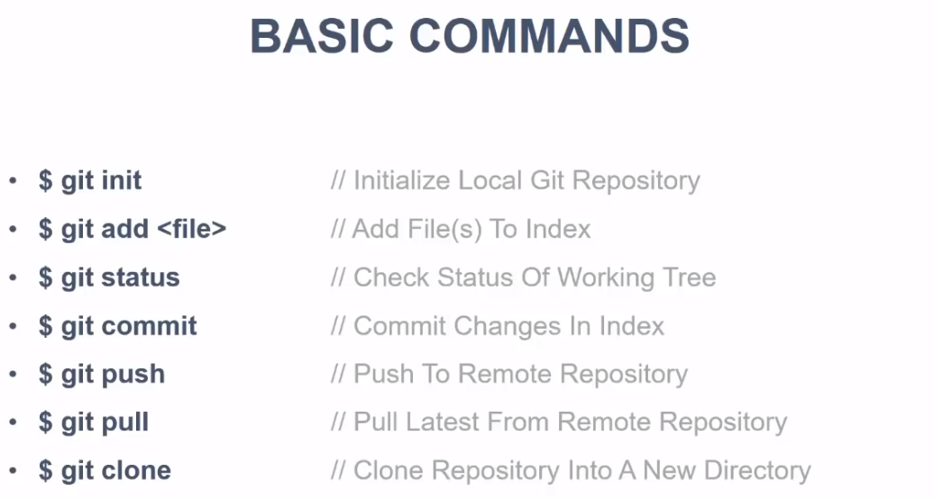

So, first of all, we want to instal “git” on our computer. For this we will simply download git for windows on the following website <https://git-scm.com/download/win>. Instal the git package so that you can use, ideally (as of 2021) VisualStudioCode as the default text editor, and be sure to pick the **git-bash** tool.

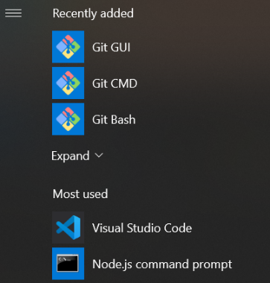Note that installing git will give you the following tools:

You will use git-bash to run the git-CMD directly on your **project-folder**, but otherwise, all git commands will remain accessible on your default windows command prompt.

You are highly encouraged to use **git-bash/git-CMD,** though, as it was designed to have best ease of access regarding to the specific **git-commands** that you’ll be using and so, since these tools are already installed with git, anyways, please do use the **git-GUI** and git-bash instead of the default windows command prompt.

### Running git-bash from your project folder (project text editor VScode)

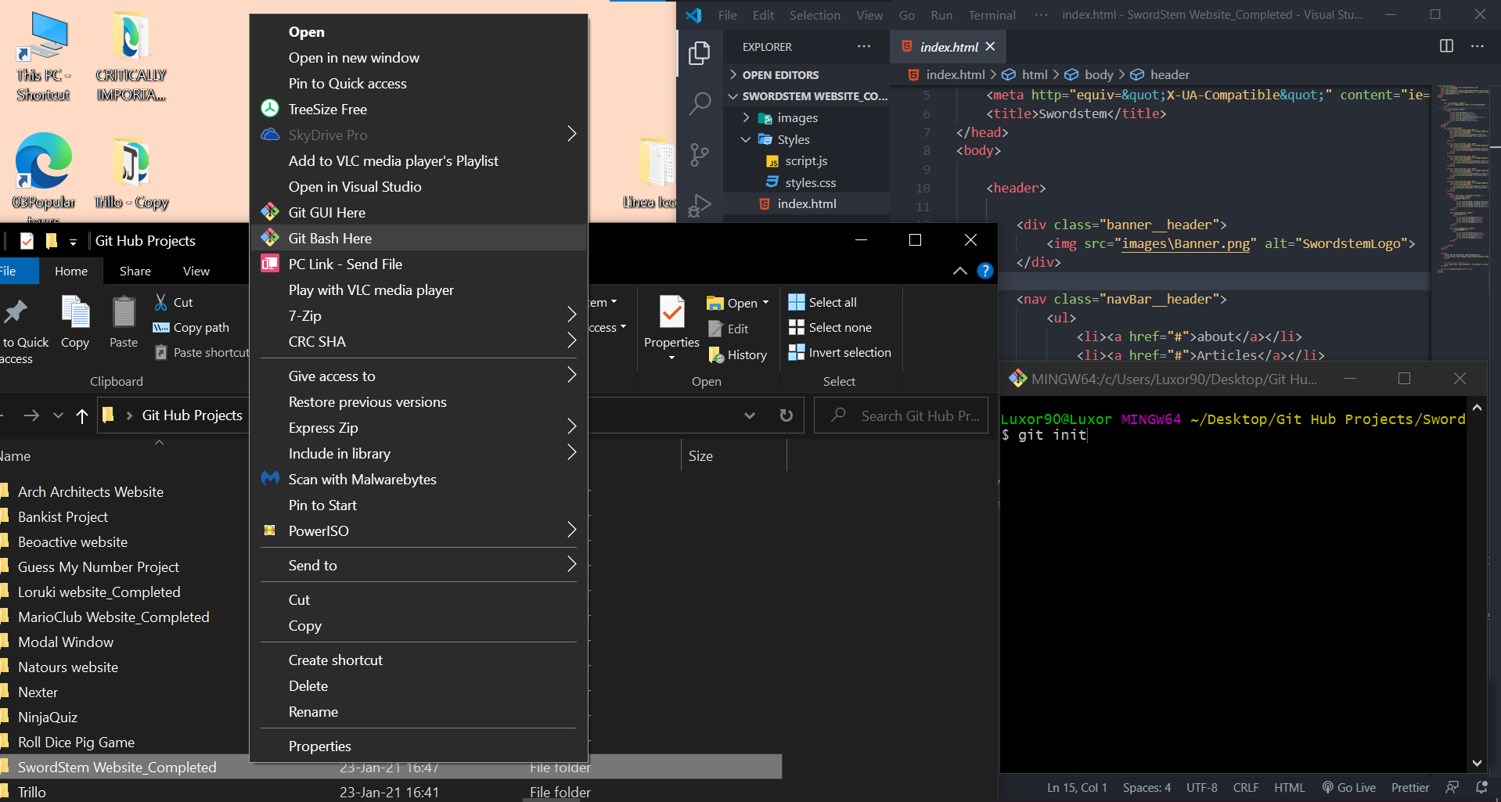

Go to your project folder, right click and choose **get bash here.** This will open git-bash command prompt, visible on the lower right corner. Now the command prompt commands effect the chosen project folder that it was opened with.

### Initializing your project folder as a Git repository

With your git-CMD oppened from the project folder, you want to initialize the project folder as a git repository, and to do this, we simply run the command **$ git init**

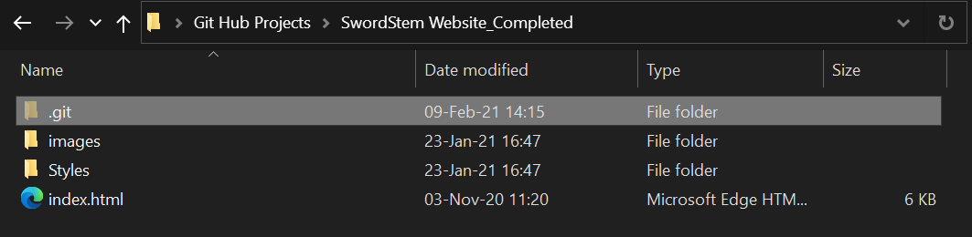This will create a **.git** folder in your project directory

Once your folder has been intitialized as a git repository, any **git commands** run in the project folder **git-CMD** will now take effect.

### Initializing your username and e-mail for git bash

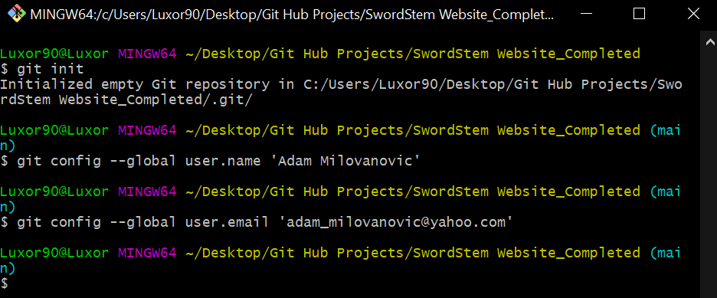

Before transfering files into your .git folder, your should intitialize the username and mail of your master repository using the following commands:

**$ git config –-global user.name ‘Adam Milovanovic’**

**$ git config –-global user.email ‘adam_milovanovic@yahoo.com’**

### Adding our project files into the empty project **.git** repository folder

In order to add files to our **staging area** we execute the **git add file.extention,** so in practice:

**$ git add index.html 🡪** will add the index.html file to our .git project folder (note that there will not be any notification on whether the file has been successfully added or not.)

To check on our files successfully added to the **staging area**  we need to execute **$ git status**

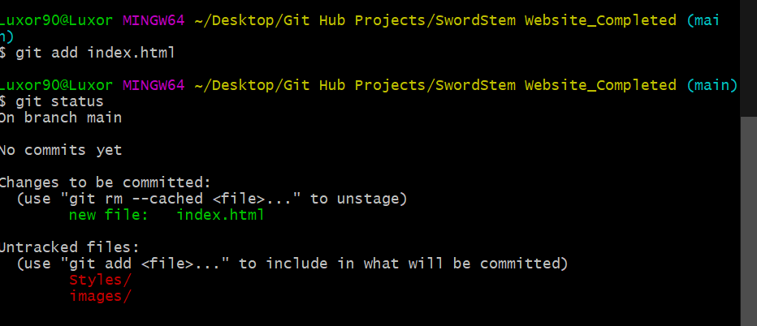

## Removing our project files from the

## **.git repository folder(staging area)**

To remove files from the .git folder (staging area) we have to execute the following command:

$ git rm –-cached fileName.fileExtention

$ git rm –-cached index.html

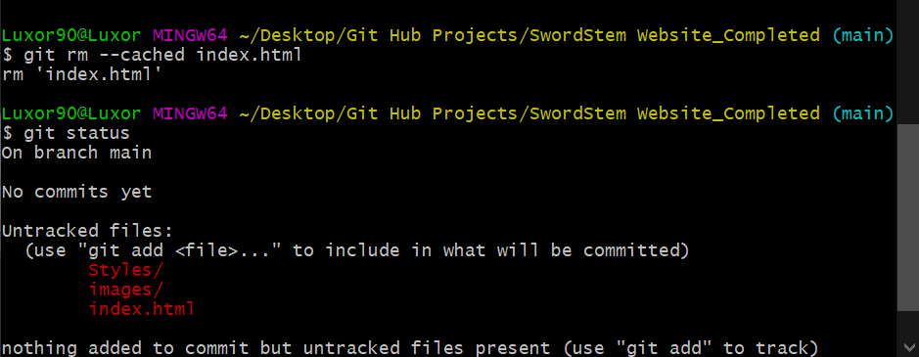

Note that we’ve removed our index.html file, and after checking **git status** the file was indeed no longer present in the **staging area.**

### **Adding all files of a certain .extention type to the staging area**

### **(.htm .scss .css .js etc…)**

We do not have to add all of our project files individually to the staging area, we can in fact add all files of a specified extention to the .git project repository folder, and save a lot of time that way.

We do this by using the (*) 🡪 All symbol, that has the same role here as it does as a css selector. The **git-CMD** command goes as follows:

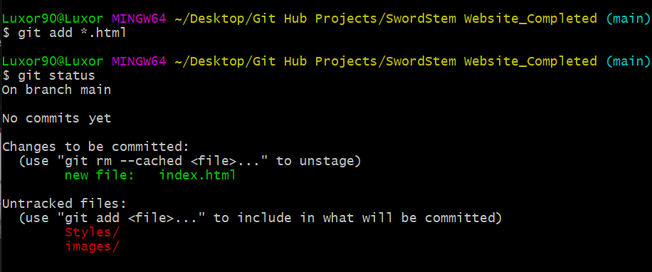

**$ git add *.html**

OR

**$ git add *.scss**

OR

**$ git add *.png**

g

### **Adding all project files to our staging area (.git project repository folder)**

In those cases where we want to add the entire project to our repository, it is very useful to know a shortcut command for doing so, and it is executed as follows:

$ **git add .** 🡪 To be perfectly clear it is **git add**  followed by a dot(.) with a space between

This will add all project files to the staging area.

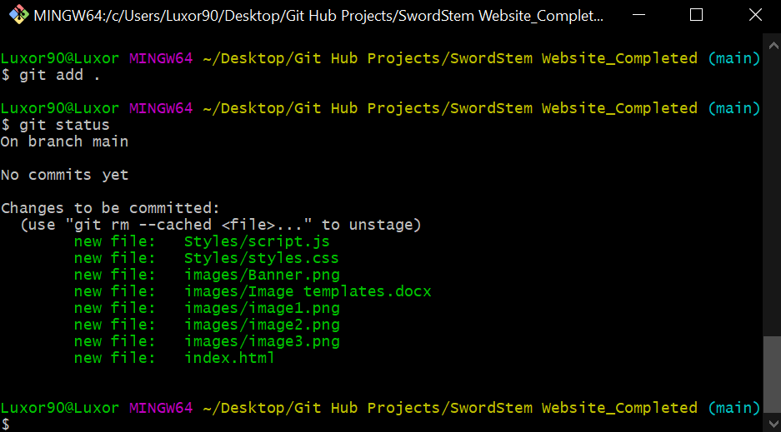

### **Making changes to the filles already added to the staging area(.git folder)**

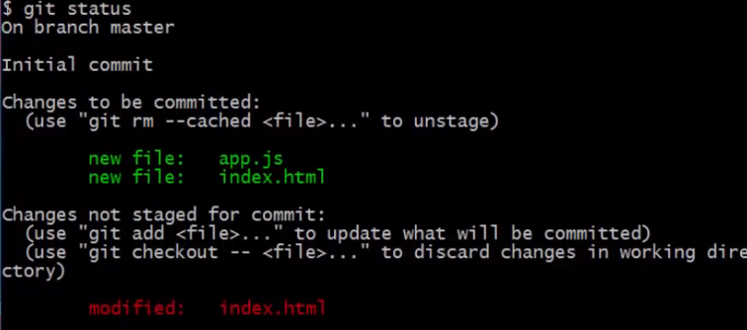

Basically whenever we make changes to the originals of the files in the staging area, copies of those modified files get pushed out of the staging area, as they are deemed to be no longer eligible to commit. We are left with two options, adding them again, which would now add the copy of the modified file to the staging area, or discarding the changes in the original files, which would push back the previous version of its copy to the staging area.

So if we already added index.html file to the staging area, and we, for example, add a new element to the .html file, if we want the copy of the now modified index.html file to return to the staging area, we would need to add it again by running **$git add index.html**

### Committing files from the staging area

There are two ways of commiting files to the staging area

The first one is basically runing the **$ git commit**  command with no additional options

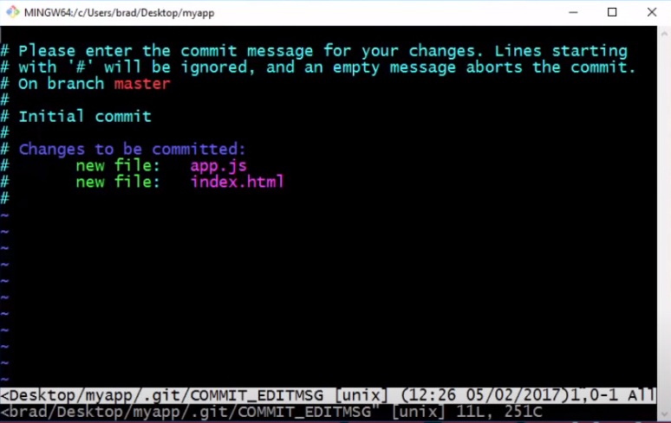This default commit will open the vim editor, and in this editor we would have to select some keyboard options in order to be able to enter any commit messages, because typing is not enabled when the vim editor opens initially.

To enter insert-mode(write mode) click the “i” key on your keyboard, and then you will be able to type and make changes in the editor.

Anything that is written without the # at the start is treated as a comment, so deleting the # before the written “initial commit” above will turn it into a comment stating “initial commit”

To get out of insert mode you simply press the “Esc” key

Then you will be transferred to the vim-editor command console at the bottom, where you would type in :**wq** to save and commit any changes you’ve made in the vim-editor

This would commit the files with the changes made in the vim-editor and retunr you to the git-CMD.



**Version 2 of commiting files to git**

### Re-committing modified files (after having committed their previous version)

Note that if we modify files that have already been commited the git-CMD will note that these files have been modified, and that those changes have not been staged for commit

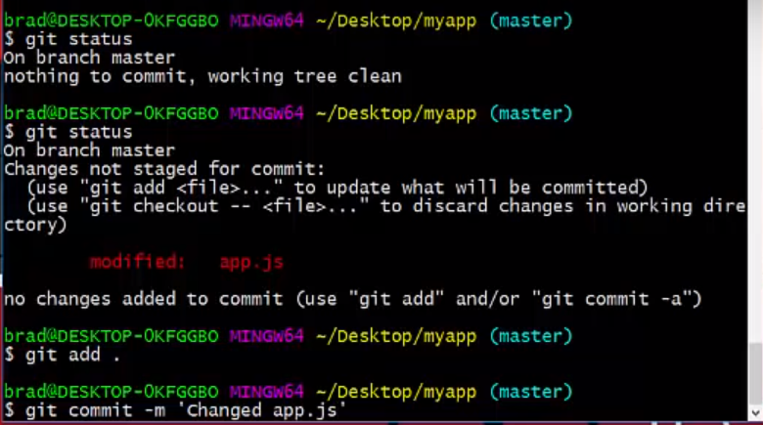

The only thing we need to do then. Is to add the modified file the staging area , or add all project files to the staging area, for that matter(overwritting existing files is not a problem) and commit those.

Now the shorthand we will be using to commit is **$ git commit –m ‘insert your commit comment’**

**Example with my local project:**

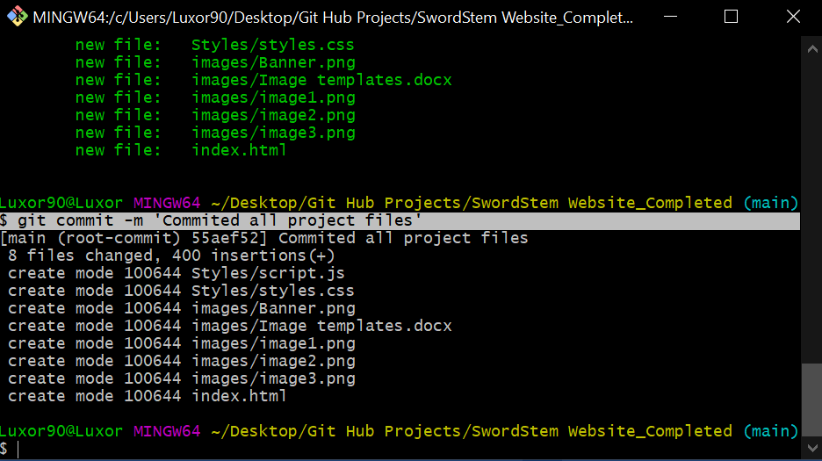

### Using the “git ignore” folder

The git ignore folder is used to store (protect) files we do not want to include into our .git repository, so that when we run general commands, like **add *.scss** or **git add .** those files specified to be ignored do not get included even if they do get encompassed within an **add** command.

So even if we run **$ git add .**  the specified “git ignore” files will not get added.

* First lets add a new command to clear our git-CMD console **$ clear**

This will give us a fresh window to work with, clearing all the previous logs from our console

Next we will create a new directory in our project Folder using the **$ touch** command . This folder will be an empty name folder with the extention **.gitignore**. This means that it can only be created directly in an editor like (VScode) or directly using the touch command in the git-CMD, as windows commandPrompt does not initialize empty-name folders. Also windows cmd does not have the touch command.(I think).

In short do the following in the git-CMD opened from your project folder.

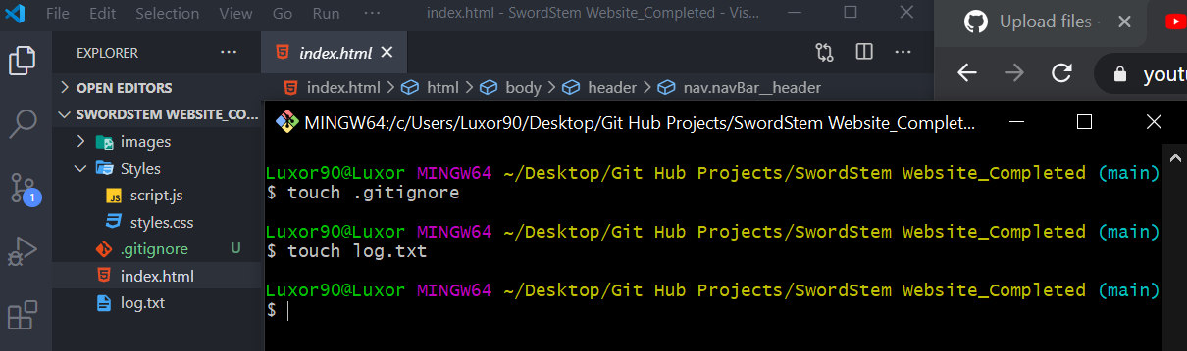

What we have here is our project folder opened in VsCode, and using the touch command we’ve created the **gitignore** folder, as well as a test file called **log.txt**  (the file that we wish to ignore, since logs represent usually files that we do not want to commit).

Also, note how the $ **touch** command creates files within our project directory, visible in visual studio.

**Next we will se how to add files to the .gitignore folder 🡪**

To add files to the .gitignore folder, you simply have to open the .gitignore file in VsCode, or any other text editor, and write (in one line) the name and extention of the file that you want to have ignored, then save it, as demonstrated in the image, and it will be ingored the next time you add all files that would otherwise include this file, to the staging area.

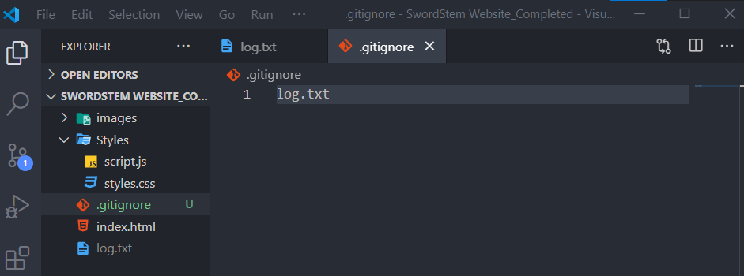

Now when we check the status of our added files we will see that the .gitignore folder has been added to the staging area, but the log.txt file that we’ve also just created is nowhere to be seen (it has been sucessfully ignored)

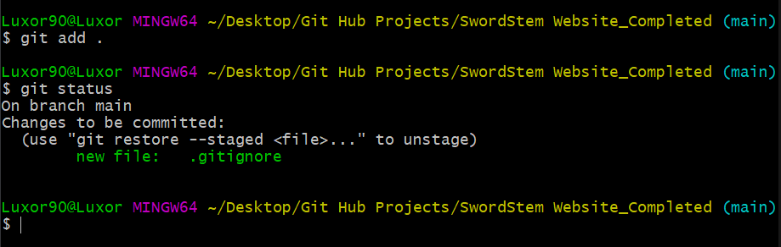

## Adding entire directories or an entire set of file-types to our .gitignore folder

## 

In the example image above we can see that adding entire directories to the git ignore is done by entering the directory address relative to the .gitignore folder. In this case we simply add the path **/css 🡪** enter css folder, and the folder will be added to the ignore list or

**/images 🡪** enter the images folder, and this folder will be added to the ignore list as well.

Note that the first element added to the ingore list is the **docs.html**  file, and below this file and the two previously mentioned directories, we have something that resembles a command, as it would be written in the **git-CMD**

**\*.txt**

**\*.png**

What these (file selectors) do is place all files with the added extention in the **.gitignore** folder.

### **Git_Branches**

Lets say you are a developer, working with a bunch of people on a single project you may want to create different branches for different stages of your project building

Master-branch 🡪 Is the primary (Main) project branch, and this is the final destination for all finalized codes.

You may create helper branches (THINK PROJECT VERSIONS) containing the same or different files as the Master(Main) branch to test out various application features and utilities and storring (commiting them) in the side branch.

This means that you may have more than one version of your project, and in the end, you decide which version will be pushed to the Master(main) branch, as the final project code.

### **Creating a new Git-Branch**

To create a new branch, simply write and execute the following command in the project folder git-CMD:

**$ git branch MyBranchName**

Note that creating a new branch does not automatically transfer us into that branch. So if you created a new branch from the Master(main) branch, you will still be in the (master) branch.

To change your current working git-branch, execute the following command:

**$ git checkout MyBranch**

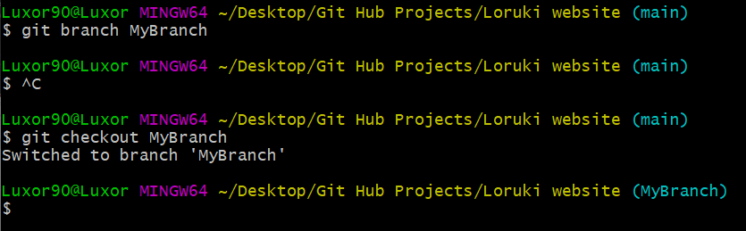

An example of how different branches on a project work:

Now that we’ve entered (MyBranch) project branch, let’s create a new .hml file from that pranch in our project folder, and commit that change

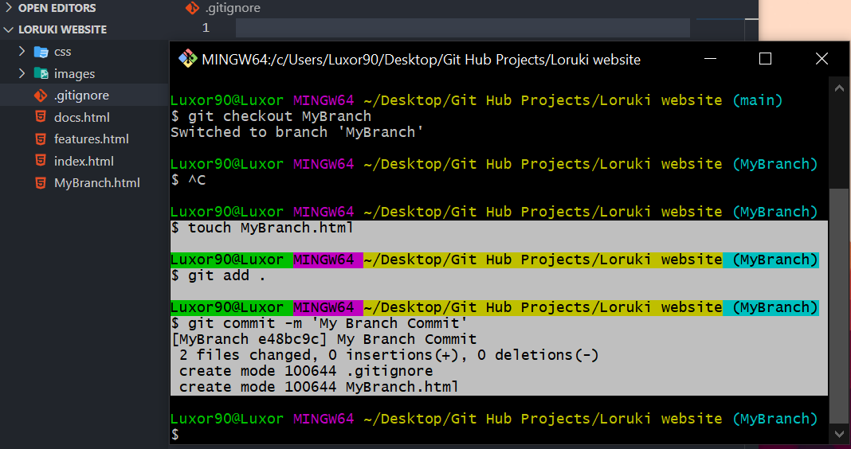

You can see on the previous image, that the new **MyBranch.html** file is created and can be viewed from VScode in the project file directory

Now this file has been created from the (MyBranch) branch. What happens if we return to the (main) branch, will the file created in a different branch still be there?

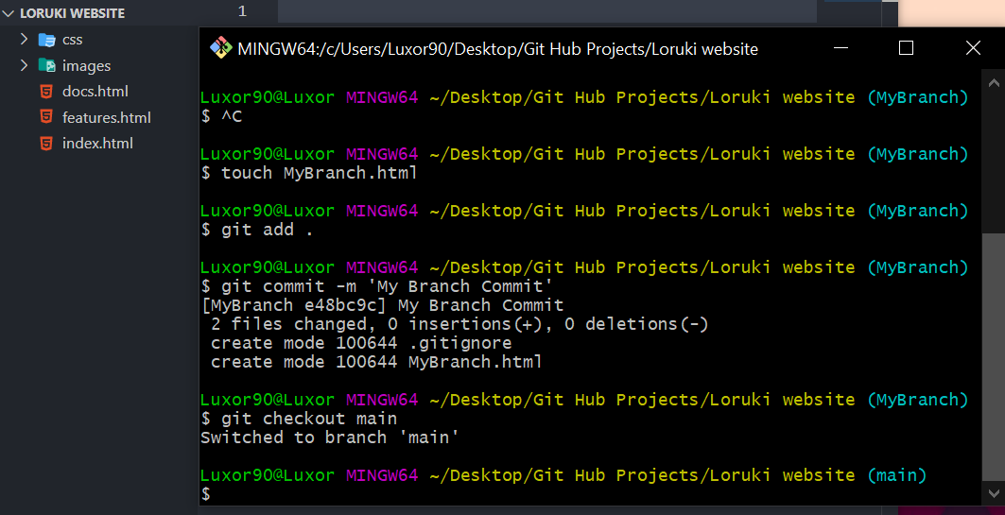

Switching branches, we notice that the file created in the (MyBranch) is not present in the (main) branch.

Also, a very important thing to note, is that the files edited in one branch will no transfer to other branches even if they are the same file names.

So **index.html** file edited in (MyBranch) will not transfer any changes or modifications to the **index.html** file in the (main) branch, and vice versa.

### **Merging two git branches**

If you want the files and modifications from one branch, to transfer and overwrite the current branch, execute the following command when you are in the branch that you want to have overwritten:

(current branch 🡪 Main)

**$ git merge MyBranch**

This will transfer all files from the **(MyBranch)** and overwrite the same-name files in the current (main) branch. So now, **MyBranch.html** would exist in both (MyBranch) and (main).

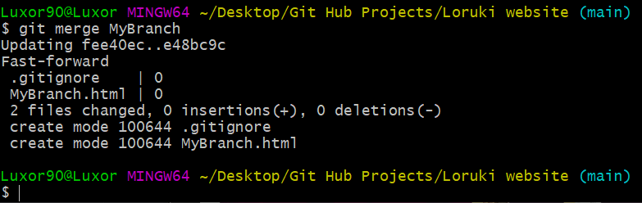

## **Working with a remote repository (GitHub)**

Create a new repository on your Git-Hub account

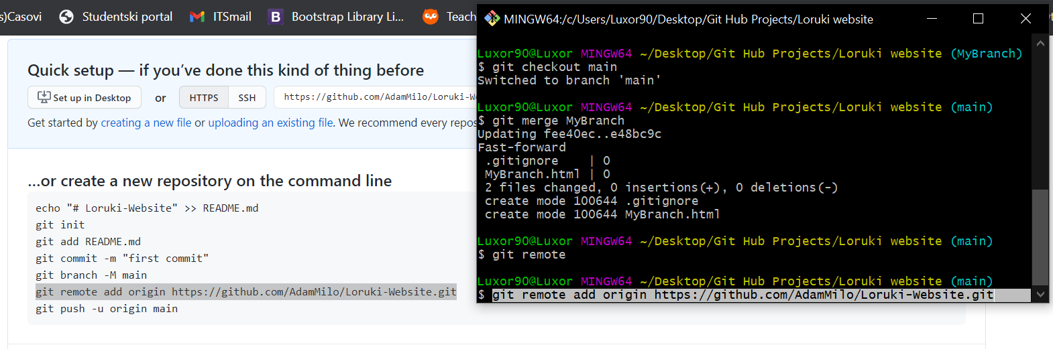

When you’ve created and named it, copy the command for the remote repository to your project folder **git-CMD** by doing the following:

**$ git remote**  🡪 Executing this code will list all of the already initialized remote repositories

And if you have no listed remote repositories, allow you to copy paste the remote repository link you got on the page of your newly created **Git-Hub** repository.

Copy and paste the entire command line as you can see, selected on the screen, then run it in your project **git-CMD**.

After runing it, again execute **$ git remote** and when you get the output: **origin** copy and paste **git push –u origin main** (This will push your project into the main branch of the remote repository)

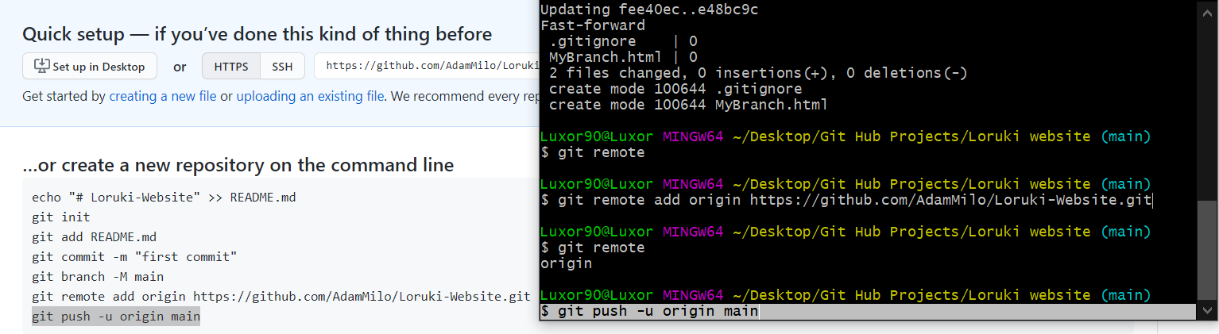

When you push your project files onto the remote repository, the website will ask to validate your login credentials



As well as ask you to authorise the remote repository to have access to the localhost (local repository) from your computer, and push the local repository files to the remote repository on **GitHub**

#### Pushing files commited on your local repository to the remote GitHub repository

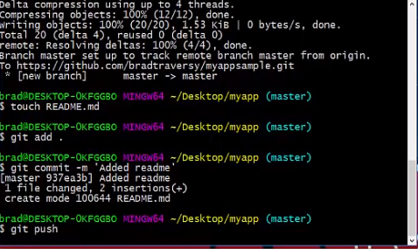Remember that whenever you add and commit new files to your local git-repository, you can transfer those files to your remote repository by running the command **$ git push**, and those files will now be pushed to your remote repository and viewable there.

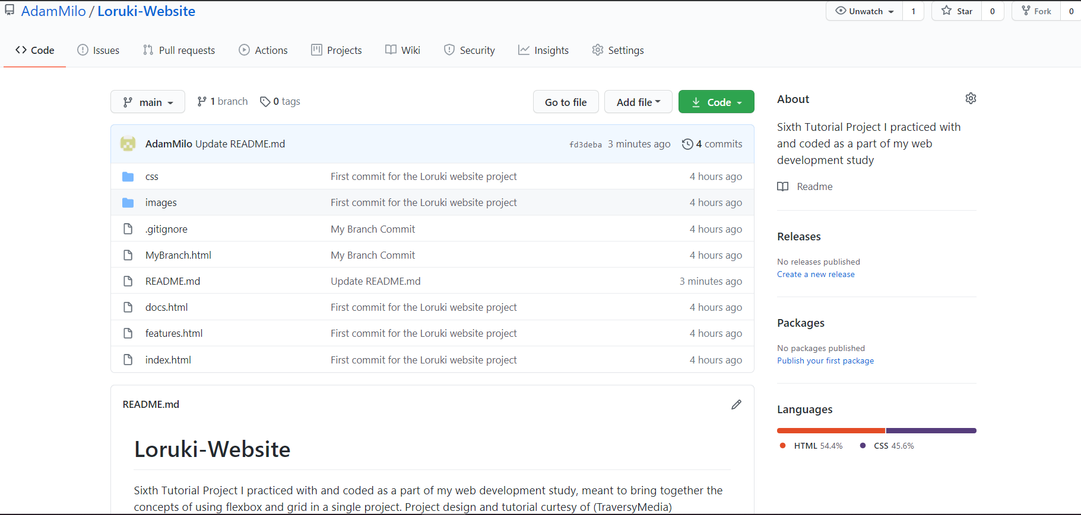

And woah, wouldn’t you know it, your local project repository is now pushed into your remote **Git-Hub** one!

Congrats, buddy! Now go and show all those people the work you’ve done for web-dev the past two months, cause now you are ready to log a bunch of kickass future projects ^^

Good job on getting this far, but remember:

“The most important step a a person can take is always the next one”

“Never. Stop. Learning.”

Go in peace, and keep kickin ass!

## Total Aside (cloning a GitHub repository)

If you want to open up a GitHub project, and dowload the entire project repository, you can simply clone it by doing the following steps:

1.Copy the link from the clone option in the gitHub repository you want to have on your local device

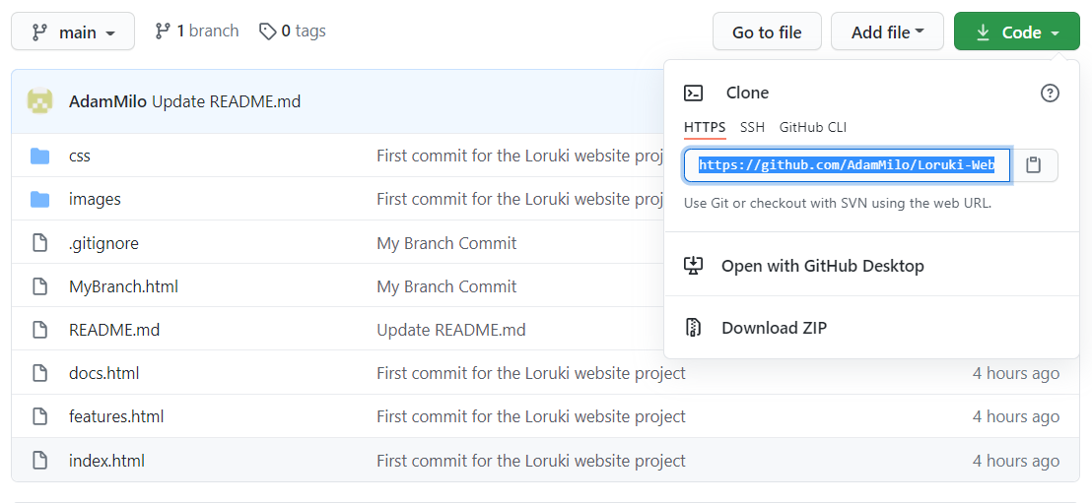

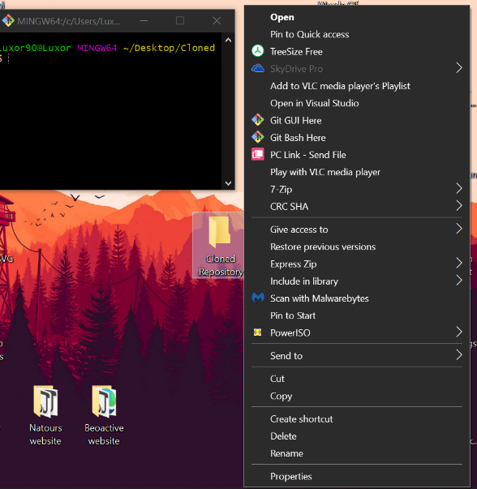2.Create a new folder and from it open **git-bash** (this will activate git-cmd for your new folder)

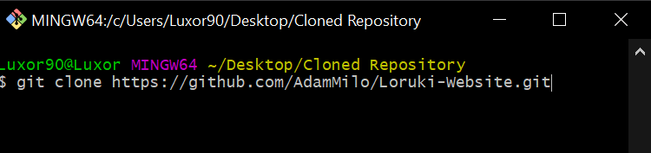Then in the git-cmd write and execute the folowing command **$ git clone (+ the repository https link)**

And wouldn’t you know it, now you have the entire repository copied to your local machine.

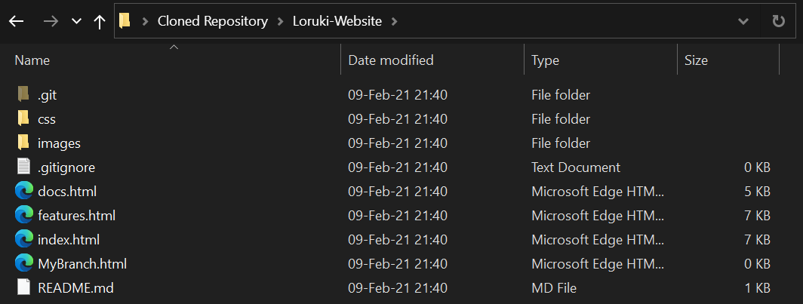

### Updating your local git repository with the changes people have made and committed on the local GitHub repository git igit

Basically, enter the git-CMD of your local project repository, and execute **$git pull**  and your local repository will be updated with all of the changes made on the remote repository Git-Hub one.

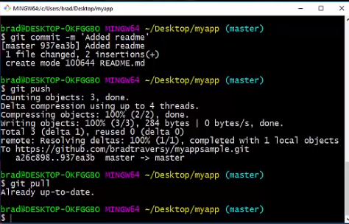

### Helper class utilities (COMPONENT)

//small margin bottom

.mb-sm {

  margin-bottom: 2rem;

}

.mb-md {

  margin-bottom: 3rem;

}

.mb-lg {

  margin-bottom: 4rem;

}

.mb-xl {

  margin-bottom: 8rem;

}